BTT Writer for the Desktop

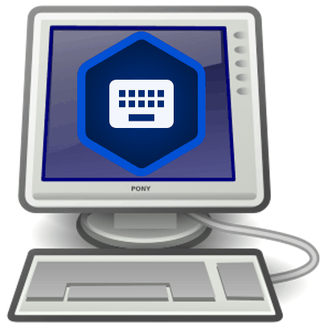

Table of Contents

Introduction to the BTT Writer for the Desktop Program 4

How do I install BTT Writer on a Desktop Computer? 4

Choosing What to Translate 9

How do I use BTT Writer for the first time? 11

Content Server Options 12

BTT Writer **– Login Options** 12

BTT Writer Terms of Use 16

How do I set up different types of translation projects? 17

How do I start a new project? 19

How do I change project properties? 25

How do I work in BTT Writer? 28

BTT Writer Layout 28

Using the Options Menu 35

How do I translate in BTT Writer? 35

Translating in a Text Project 36

Translating Resources 41

Translating Footnotes 44

Uploading/Exporting Your Work 47

Upload to the Server 48

Export to USFM File 49

Export to PDF File 50

Export Project File 52

Recovering Deleted Translation Text 53

Importing a Project 53

Import from Server 54

Import Project File 56

Import USFM File 57

Import Source Text 59

Importing Duplicate Projects 59

Merge Conflicts 60

Publishing Content 61

Self-Publishing 61

Source Text Publishing 61

Modifying Program Settings 64

General Settings 65

About Settings 67

Legal Settings 67

Advanced Settings 68

Updating Program Elements 68

Updating Source Text Lists 69

Downloading Available Source Texts 70

Updating List of Available Target Languages 74

## [Introduction to the BTT Writer for the Desktop Program](http://help.door43.org/en/knowledgebase/9-translationstudio/docs/10-introduction-to-the-translationstudio-android-program)

BTT Writer for the Desktop enables translators to do offline translating of the Bible or of Bible resources. It can be used for two purposes:

* For translators to translate the Bible (or Open Bible Stories) from English to a gateway language, or from a gateway language to a mother tongue
* For Gateway language translators to translate Bible resources from English to a gateway language

The program contains the content that needs to be translated as well as translation helps (See: Using the Resources). You can share information directly from device to device, and you can upload finished content to the server where it can be digitally published.

## How do I install BTT Writer on a Desktop Computer?

**Note:** This process requires an Internet connection.

* Go to: <https://bibleineverylanguage.org/>
* Click **Tools**.  
  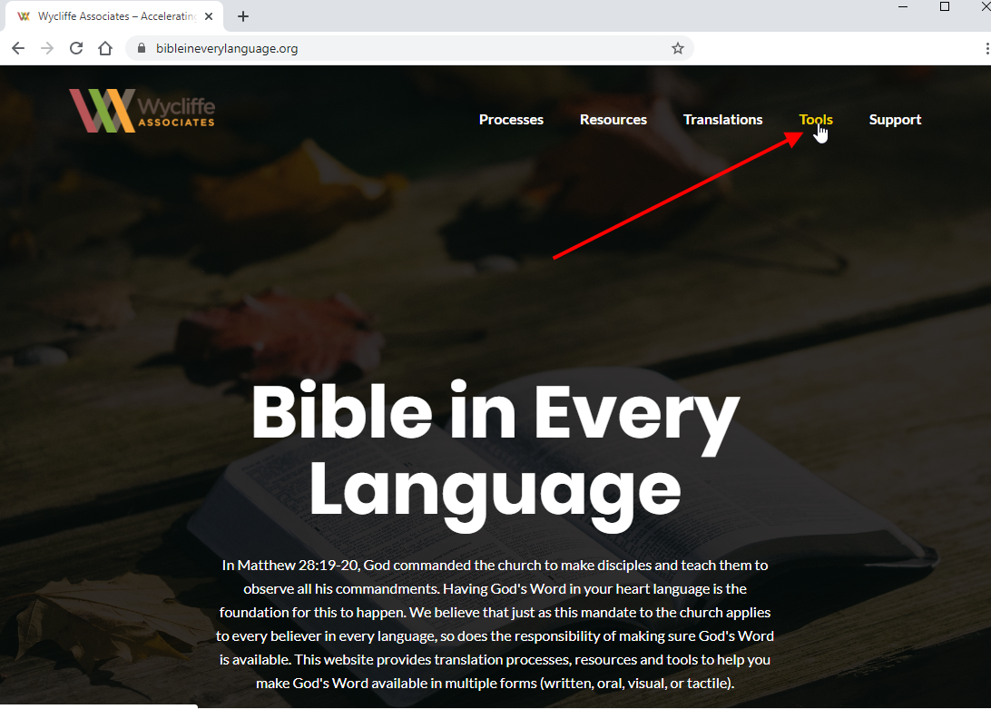  
    
  **Note**: If you don’t see the menu items across the top, click the Menu icon  to display them.
* Scroll to the BTT Writer section and click **DOWNLOAD**.  
  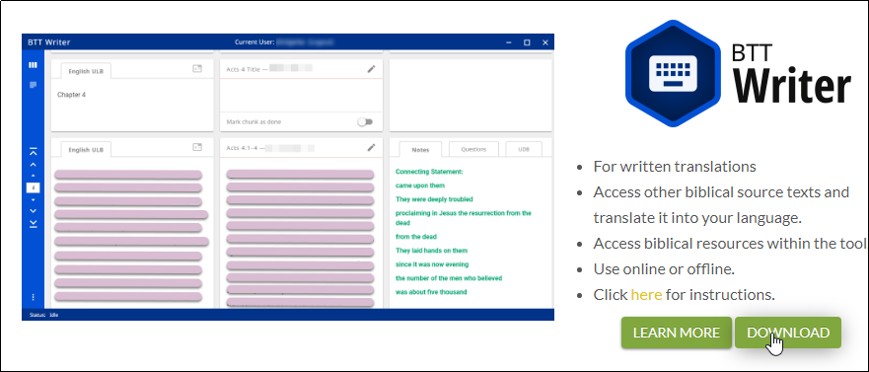
* Click **Desktop Download**.  
  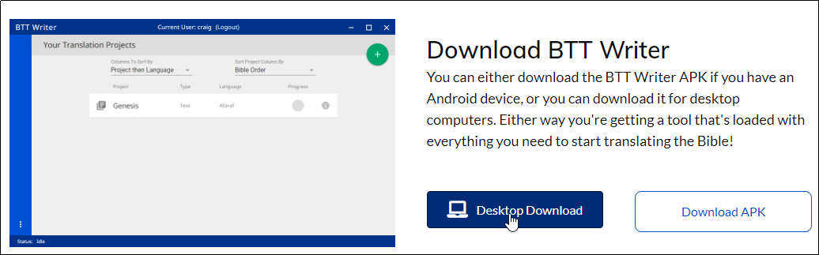
* Click the appropriate file for your computer:
  + The file with “linux” in the name is for a Linux operating system.
  + The file with “osx” in the name is for an Apple Macintosh operating system.
  + The file with “win_x32” in the name is for a 32-bit Windows operating system.
  + The file with “win_x64” in the name is for a 64-bit Windows operating system.  
      
    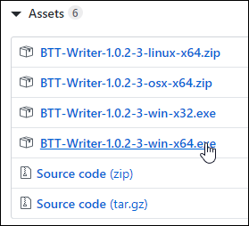  
      
    **Note:** To determine if your Windows PC is a 32-bit or a 64-bit operating system, open the Control Panel and click System.
* Designate where you want to save the file.  
  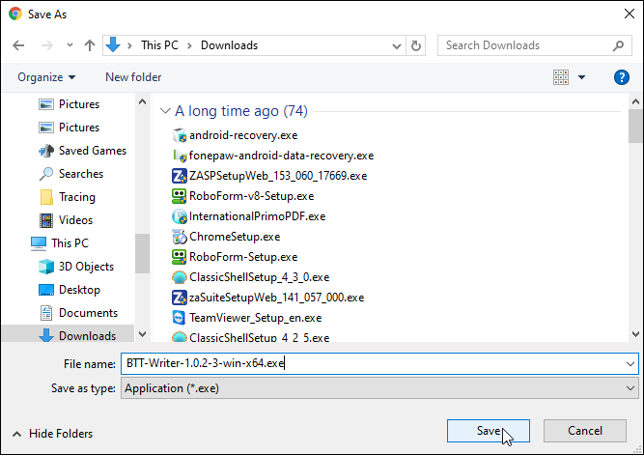
* Allow the file to download to the computer.
* Double-click the file name to start the install, or right-click it and select **Open** from the context menu.  
  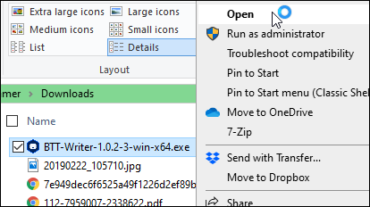
* If you get a message from Windows Defender, click **More Info**, and then click **Run Anyway**.   
  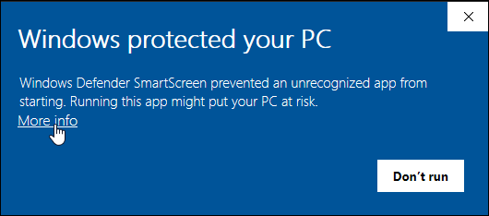  
    
  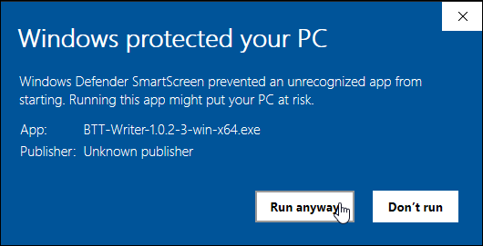
* Click **Run** or **Yes** on the Warning message window and any other warning messages.
* Choose the language that will be used during the installation from the drop-down menu.  
  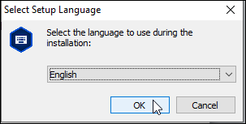
* Click **Next** on the 'Welcome to the BTT Writer Setup Wizard' window.  
  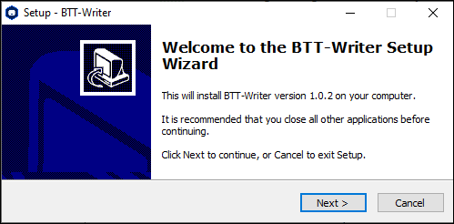
* Select the **I accept the agreement** radio button for the software license. Click **Next**.  
  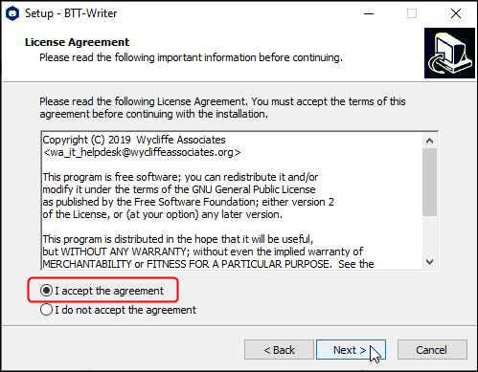
* Select the choice to '**create a desktop icon**' if you wish. Click **Next**.  
  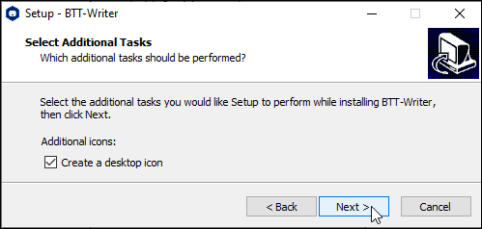
* Click **Install**.   
  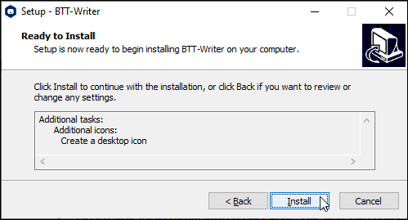
* Please wait for the program to be installed.  This may take several minutes. The installer installs BTT Writer and Git, which is a version control system.  
  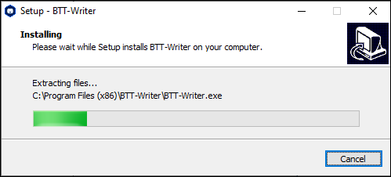
* At the *Completing the BTT Writer Setup Wizard* window, click **Finish** to complete the installation.  
  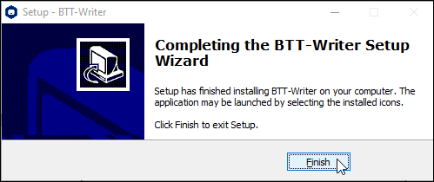

## Choosing What to Translate

At some point, the translation team must figure out what they should translate first, or, if they have already done some translation, what they should translate next. There are several factors that need to be considered:

* What does the church want to be translated?
* How experienced is the translation team?
* How much Biblical content has been translated into this language?

The answers to these questions are important. But remember this:

**Translation is a skill that grows with experience.**

Because translation is a skill that grows, it is wise to start translating content that is less complicated so that the translators can learn the skill while translating something simple.

***Translation Difficulty***

Wycliffe Bible Translators have rated the difficulty of translating the different books of the Bible. In their rating system, the most complicated books to translate receive a level 5 difficulty. The easiest books to translate are a level 1.

In general, books that have more abstract, poetic, and theologically loaded terms and ideas are more difficult to translate. Books that are more narrative and concrete are generally easier to translate.

**Difficulty Level 5 (Most Difficult to Translate)**

* + Job, Psalms, Isaiah, Jeremiah, Ezekiel
* New Testament
  + Romans, Galatians, Ephesians, Philippians, Colossians, Hebrews

**Difficulty Level 4**

* Old Testament
  + Leviticus, Proverbs, Ecclesiastes, Song of Solomon, Lamentations, Daniel, Hosea, Joel, Amos, Obadiah, Micah, Nahum, Habakkuk, Zephaniah, Haggai, Zechariah, Malachi
* New Testament
  + John, 1-2 Corinthians, 1-2 Thessalonians, 1-2 Peter, 1 John, Jude

**Difficulty Level 3**

* Old Testament
  + Genesis, Exodus, Numbers, Deuteronomy
* New Testament
  + Matthew, Mark, Luke, Acts, 1-2 Timothy, Titus, Philemon, James, 2-3 John, Revelation

**Difficulty Level 2**

* Old Testament
  + Joshua, Judges, Ruth, 1-2 Samuel, 1-2 Kings, 1-2 Chronicles, Ezra, Nehemiah, Esther, Jonah
* New Testament
  + *none*

**Difficulty Level 1 (Easiest to Translate)**

* *none*

**Open Bible Stories**

Though Open Bible Stories was not assessed according to this rating system, it should fall under Difficulty Level 1. We recommend that you begin by translating Open Bible Stories. There are many good reasons to start by translating Open Bible Stories:

* Open Bible Stories was designed to be easily translated.
  + It is largely narrative.
  + Many difficult phrases and words have been simplified.
  + It has many pictures to help the translator understand the text.
* Open Bible Stories is much shorter than the Bible or even the New Testament, so it can be quickly completed and distributed to the Church.
* Since it is not Scripture, Open Bible Stories removes the fear that many translators have of translating the Word of God.
* Translating Open Bible Stories before translating the Bible gives the translators experience and training in translation, so that when they translate the Bible, they will do it well. By translating Open Bible Stories, the translation team will gain:
* Experience in creating a translation and checking team
* Experience in doing the translation and checking process
* Experience in using the translation tools
* Experience in resolving translation conflicts
* Experience in getting church and community participation
* Experience in publishing and distributing content
* Open Bible Stories is a great tool to teach the church, evangelize the lost, and train the translators in what the Bible is all about.

You can work your way through the Stories in whatever order that you want, but we have found that Story #31 (see <http://ufw.io/en-obs-31>) is a good first story to translate since it is short and easy to understand.

***Conclusion***

Ultimately, the church needs to decide what they want to translate, and in what order. But because translation is a skill that improves with use, and because the translation and checking teams can learn so much about translating the Bible by translating Open Bible Stories, and because of the immense value that the translated Open Bible Stories gives to the local church, we highly recommend starting your translation project with Open Bible Stories.

After translating Open Bible Stories, the church will need to decide if it would be more beneficial to start with how everything began (Genesis, Exodus) or with Jesus (New Testament gospels). In either case, we recommend starting Bible translation with some of the Difficulty Level 2 and 3 books (like Genesis, Ruth, and Mark). Finally, after the translation team has a lot of experience, then they can start translating Difficulty Level 4 and 5 books (like John, Hebrews, and Psalms). If the translation team follows this schedule, they will make better translations with far fewer mistakes.

## How do I use BTT Writer for the first time?

Complete these steps to use BTT Writer for the first time:

1. Open BTT Writer:

* If you chose to create a desktop icon during installation, double-click the desktop icon.  
  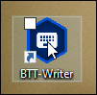
* If you did not choose to create a desktop icon you will need to find the program:
  + Click the "start" icon  on your computer or press the Windows key 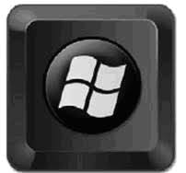 on your keyboard.
  + Find BTT Writer in the list of programs and click to open it.  
    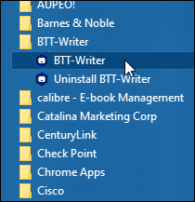

1. As the program loads, a splash screen displays the version of BTT Writer that you have installed. Wait a few moments while the program finishes loading.   
   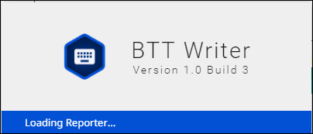|
2. The program opens to a screen that enables you to create or log in to your account. See BTT Writer - Login Options for more information.

### Content Server Options

BTT Writer enables you to upload your work to and import projects from an online content server. By default, BTT Writer connects to the Wycliffe Associates Content Server (WACS). If you would rather upload to the Door43 Content Server (DCS), you can change the server in the Server Suite setting. See Modifying Program Settings. You can change this setting before you log in if you wish.

### BTT Writer **– Login Options**

When BTT Writer first opens, the User Profile page displays a request to create or log in to a user account.  
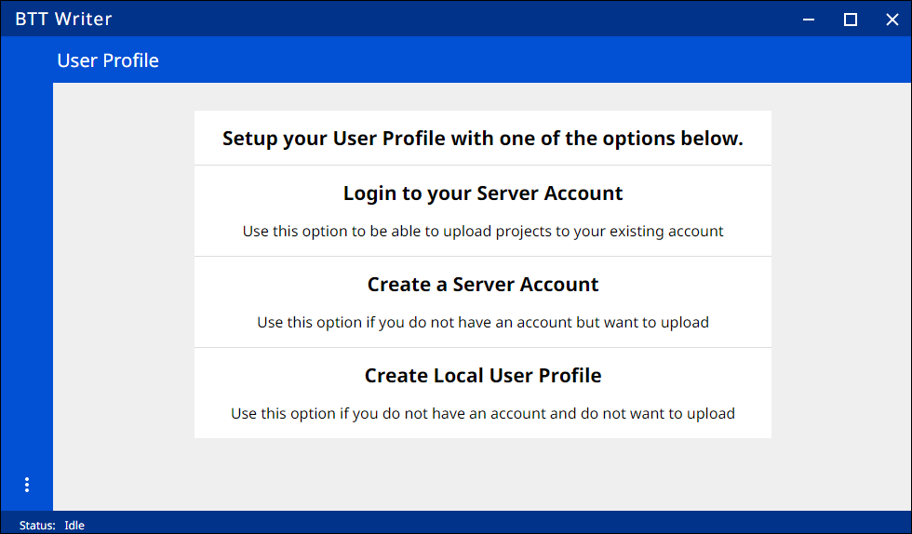

**NOTE:** You may use a pseudonym instead of your real name. A pseudonym is a name that cannot be traced back to you. You may wish to use a pseudonym if you are working in a sensitive part of the world.

#### **Which Type of Account Do I Want to Use?**

**Local User Profile** – user does not need to be connected to the internet but has full use of the program except for uploading to or downloading from the content server. You may want to start with an offline account and then switch to a server account later when you want to upload your work (the work is attached to the device, not to the account). If you want to use an offline account, skip to the Using a Local User Profile section.

**Server Account** – user has full use of the program and can upload to the content server (requires Internet connection.)

##### **Using an Existing** Server Account

If you already have a server account, you can log in with it. If not, and if you want to be able to upload to Server, skip to the Using a New Server Account section. If you are not connected to the internet or do not wish to upload to the server, skip to the Using a Local User Profile section.

To use your existing server account:

1. On the opening screen, click **Login to your Server Account**.   
     
   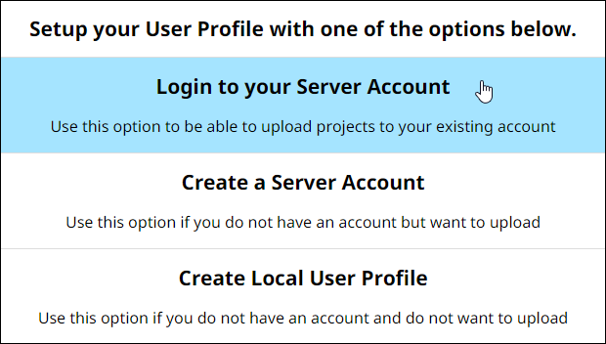
2. The login screen opens. Type in your Server account information and click **LOGIN**.  
   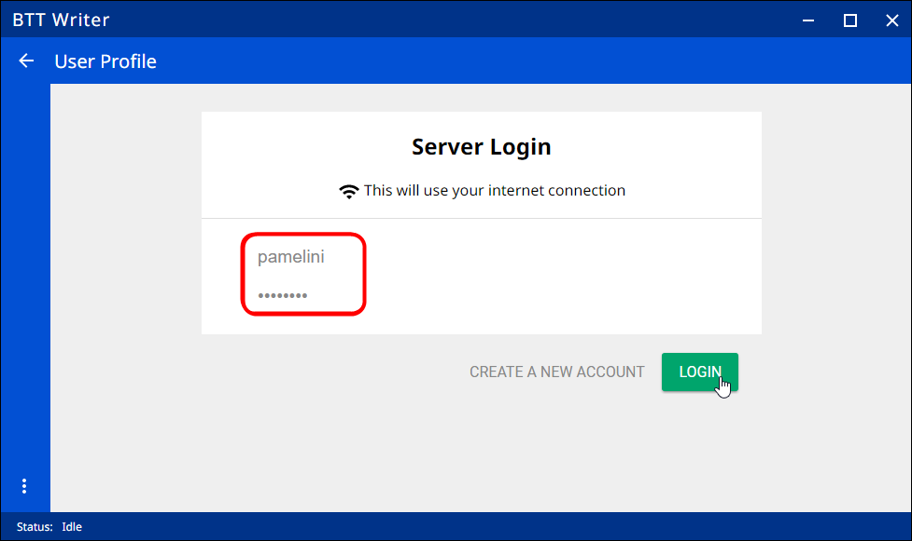
3. Skip to the BTT Writer Terms of Use section.

##### Using a New Server Account

If you do not have a server account, but you wish to be able to use an internet connection to upload your work to the server, you can create a Server account. If you are not connected to the internet or do not wish to upload to the server, skip to the Using a Local User Profile section.

1. On the opening screen, click **Create new Server Account** to create a new Server user account. (This requires an Internet connection.)  
     
   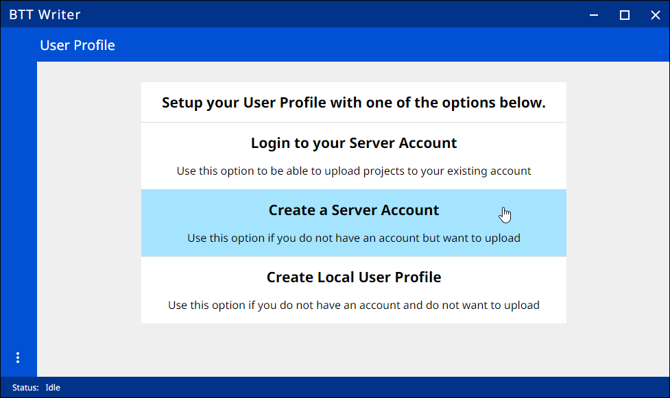
2. The Server Account Creation window opens.   
      
   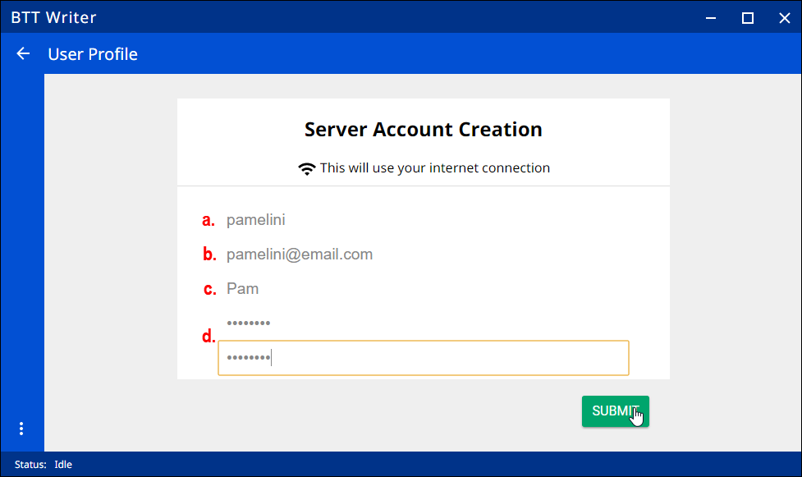
   1. Click the **Username** field and type the username that you want use to log in to the app.  
      **Note**: Because names are publicly available, you may prefer to use a pseudonym. Make up any pseudonym of your choice.
   2. Click the **Email** field to enter your email address. If you are using a synonym, you may want to first set up an email address that does not contain your name.
   3. Enter your name or pseudonym in the **Full Name or Pseudonym** field. This is your display name, which can be different from the username that you use to log in. This is the name that will be listed as a contributor to any projects on this device. If you used a pseudonym in step (a), use the same pseudonym here.
   4. Enter a password in both fields.
   5. Click **Submit** to begin registration.
3. Skip to the BTT Writer Terms of Use section.

##### Using a Local User Profile

If you do not want use a Server account at this time or are not able to connect to the Internet, you can create a local user profile.

1. On the opening screen, click **Create Local User Profile**. The login screen opens.  
     
   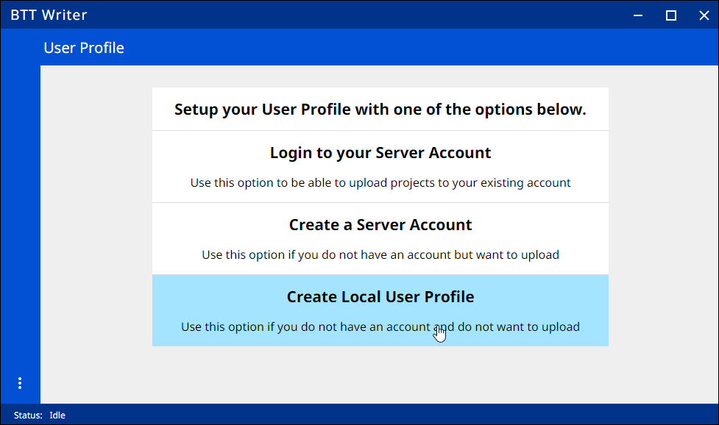
2. Click the **Your Name or Pseudonym** field. Type your username or pseudonym into the field, and then click **OK**.  
    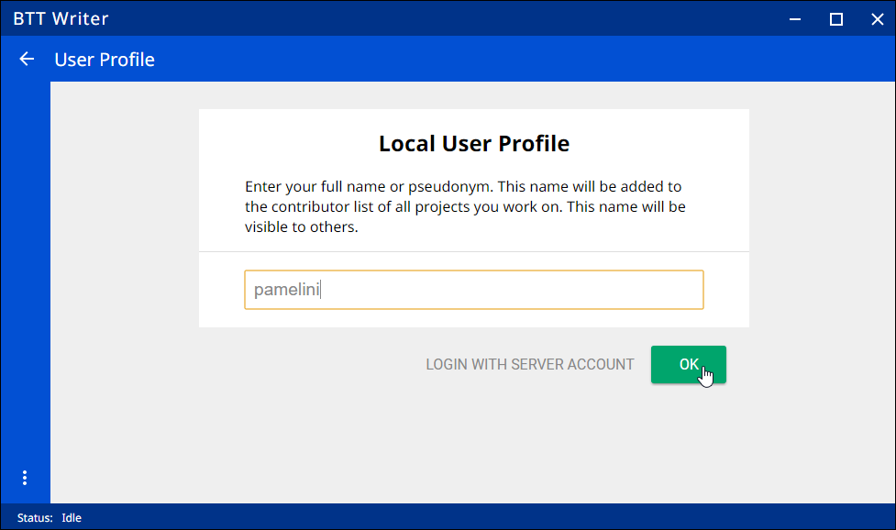

**NOTE:** You may use a pseudonym instead of your real name. A pseudonym is a name that cannot be traced back to you. You may wish to use a pseudonym if you are working in a sensitive part of the world.

1. Skip to the BTT Writer Terms of Use section.

##### **Changing Login Account Settings**

**You do not need to log out of the BTT Writer program unless you want to change the user you are logged in as. At any time you can log out to access the initial screen where you can change the login or translator settings. To log out, perform either of the following actions:**

* From the *Your Translation Projects* screen (Home screen):
  + Click the 3-dot icon  at the lower left to invoke the options menu.
  + Click **Log out.**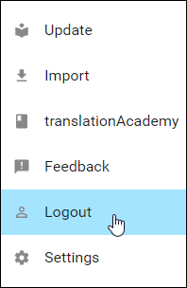

OR

* Click **Logout** at the top center of the screen next to the username.  
  

### BTT Writer Terms of Use

After you have logged in for the first time, BTT Writer displays the Terms of Use. Read and agree with each of the statements in the Terms of Use by performing the following steps:

1. Click each statement.  
   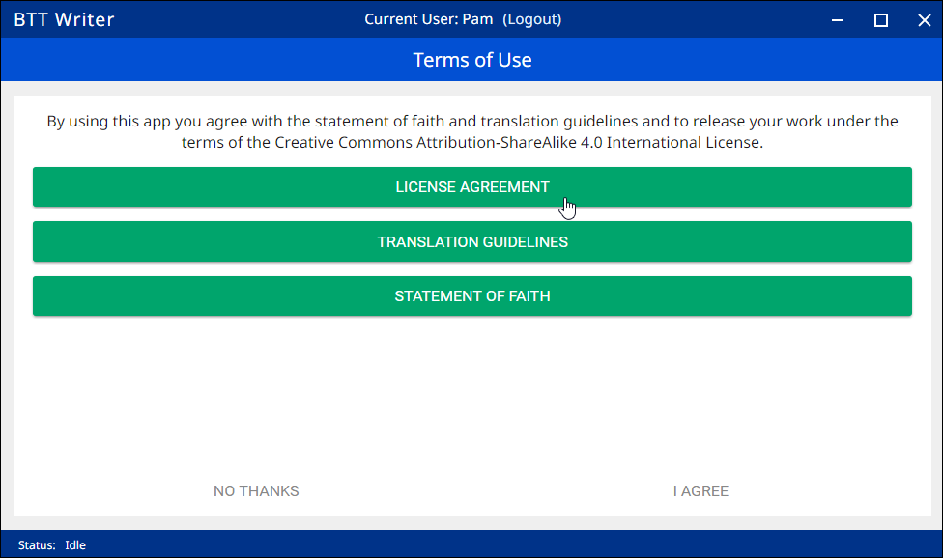
2. Scroll through the text to read the entire statement. Click **Close** for each statement.  
   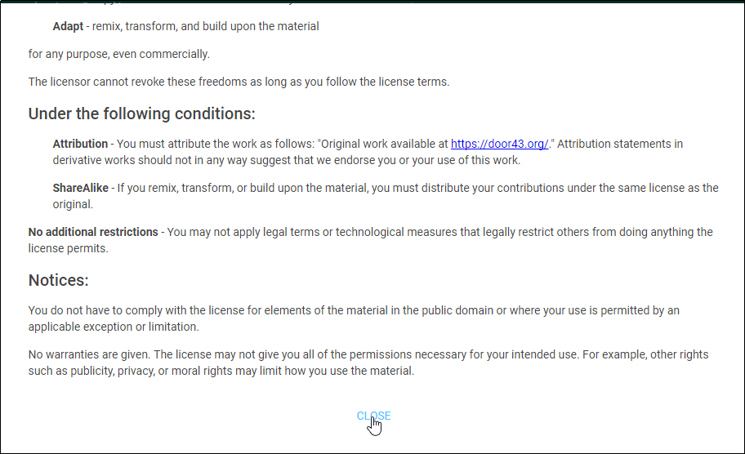
3. When you have read all statements, click **I Agree**.   
   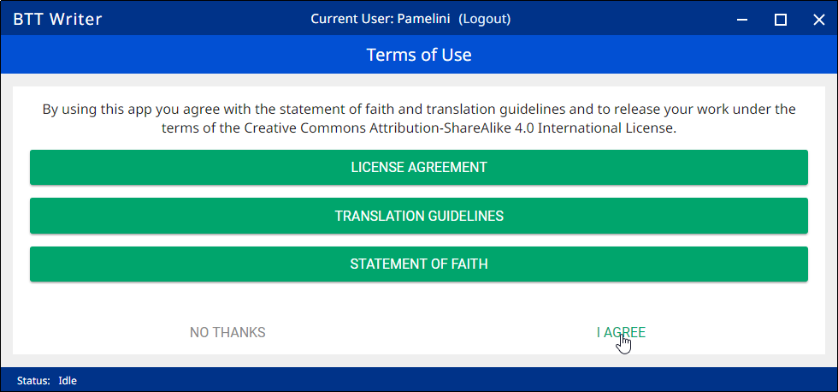

**Note:** At any time you can view the License Agreement, Statement of Faith, Translation Guidelines and the Software Licenses information from the Settings Menu. (See: Modifying Program Settings)

1. The program opens to the *Your Translation Projects* screen (which is the Home screen). The first time you use the program you have no existing projects, so the Home screen displays a welcome message.

### How do I set up different types of translation projects?

There are two types of projects that you can do in BTT Writer:

1. A regular text project, where you translate the Bible or Open Bible Stories (OBS) from one language to another
2. A Gateway Language (GL) project, where you translate Bible resources (Notes, Questions, or Words) from English into a Gateway language

#### How do I set up to translate the Bible or Open Bible Stories (regular text project)?

If you are using BTT Writer to translate the Bible or Open Bible Stories, you need to enable Blind Edit Mode. You can enable Blind Edit Mode at any time for existing projects or for new projects that are doing this type of translation.

To enable Blind Edit Mode, perform the following steps:

1. Click the three dots at the lower left of the window to open the Options menu and select Settings.   
   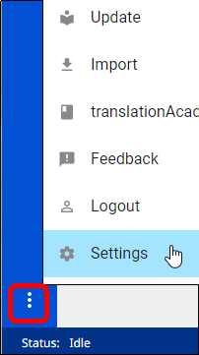
2. In the Settings window select the checkbox next to Blind Edit Mode to enable it. 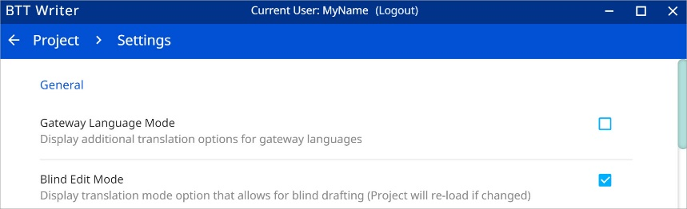
3. In the breadcrumbs at the top left of the screen, click Home to return to the home screen.  
   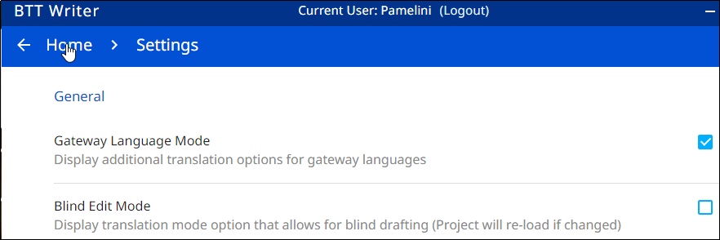

#### How do I set up to translate Bible resources (GL project)?

If you are using BTT Writer for a GL project, there is a setup step that you need to perform prior to starting a project.

You must set BTT Writer to use Gateway Language Mode so that the resources are available to be translated. Setting this mode does not affect existing projects, if any. It affects only the options that you see when creating new projects.

To use Gateway Language Mode for new projects, perform the following steps:

1. Click the three dots at the lower left of the window to open the Options menu and select Settings.   
   
2. Select the checkbox next to **Gateway Language Mode** to enable it.  
   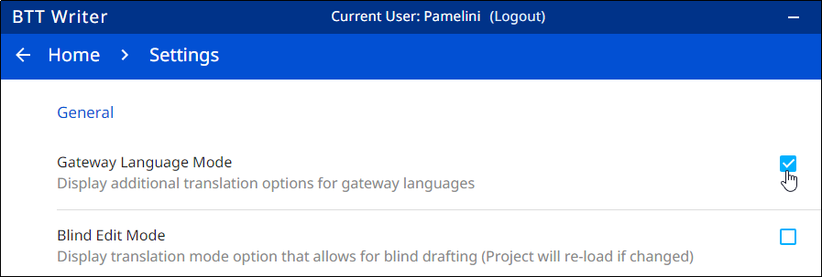
3. In the breadcrumbs at the top left, click **Home** to return to the Home screen.  
   

Once you have set Gateway Language Mode, the Bible resources project categories will be available for you to choose, but you will not be able to create a regular text project until you unset Gateway Language Mode.

### How do I start a new project?

The definition of a translation project consists of:

1. Specifying the **target language** - the language *into which* you will be translating
2. Selecting a **project category** - *what* you will be translating, such as Open Bible Stories, a book of the Bible, or Bible resources (Words, Notes, or Questions)
3. Choosing a **source text** - the language and text *from which* you will be translating, such as the English ULB (Unlocked Literal Bible)

To start a translation project, you must specify each of these elements.

Begin by clicking the plus sign icon on the Home screen to start defining a new project. When you first start using BTT Writer, there is also a **Start a New Project** button on the Home screen that you can use to start a new project. (The Start a New Project button is available only if you have not previously created any projects.)  
  
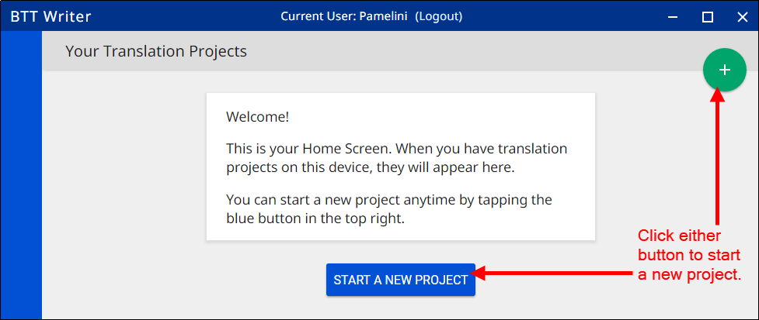

#### *How do I select the target language?*

All BTT Writer projects require a target language (the language *into* which you will be translating).

When you create a new project, the first step is selecting the target language, so BTT Writer presents you with a language list that is alphabetical by the language code shown in the right column of the list.  
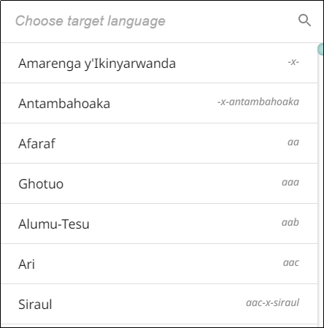

To choose your target language (the one you will be translating *into*), you can either scroll down the language list to find the target language **OR** you can search for the target language. To search, perform the following steps:

1. In the search field and the top left of the language list, type the first few letters of your language to narrow the list.   
   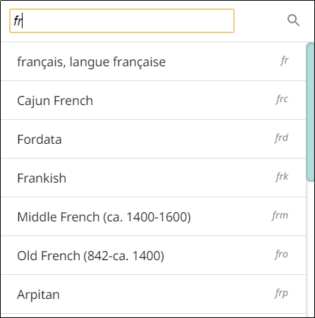
2. Click your target language to select it.  
   **Note**: If you are creating a sample project and not an actual translation project, please select “English demo1” or “English demo2” as the target language.  
   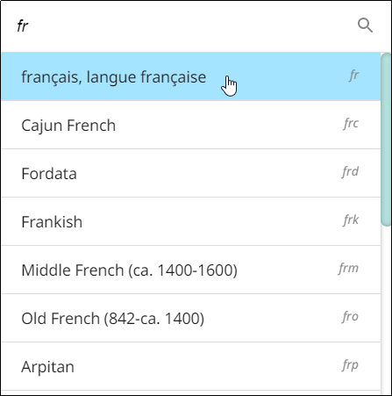

##### What if you cannot find the desired target language?

If you do not see your language in the list of target languages, first try alternate spellings, dialect names, and any variant names for your language. If you still can't find it, you can request that your language be added to the list of available languages.

The best way to submit a request is to send an email to help@door43.org. Another method is to use the Feedback option from the options menu to submit a Bug Report. In either case, please provide as much information as you can about the language, such as the local name of the language, any other names it is known by, approximate number of speakers, where it is spoken, any similar languages, any published works in that language, etc.

Use **Feedback** in the 3-dot options menu to request a new language:

1. From any screen in BTT Writer, click the 3-dot icon  on the bottom left.
2. In the list of options, click **Feedback**.
3. The **Feedback** screen opens. Type the name of the language you would like added to BTT Writer. Provide the location of the speakers and other names the language is known by. If you used a language that is already in the program, tell which language you used.
4. Click **Confirm** to send your request.  
   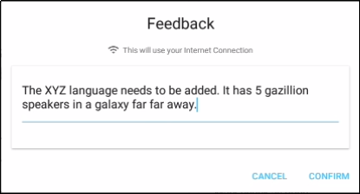

Note that even after requesting a new language, certain approvals are required before it will be added to BTT Writer. Until your language is added to the program, use *English demo1* or *English demo2*. You will need to use the Feedback option from the options menu to send a comment stating that you used another language for your own. Once your translation has been received, the support staff will change the target language to the correct language. Your translation will then be listed in your language.

#### How do I select the project category?

When you create a new project, the next step is selecting the project category, which is the type of project you will be working on, such as a book of the Bible, Open Bible Stories, or one of the translation resources (notes, words, or questions).

To designate what to work on for this project, complete the following steps:

1. Choose a project from the *Old Testament*, *New Testament*, or *Other* to start translating.  
     
   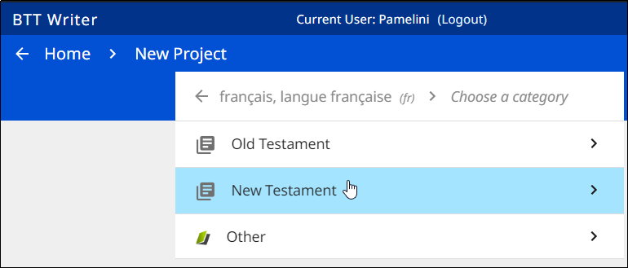
2. The next step depends on the category you chose:
   1. **If you chose either the Old or New Testament**:
      1. You next choose a book for the project.  
         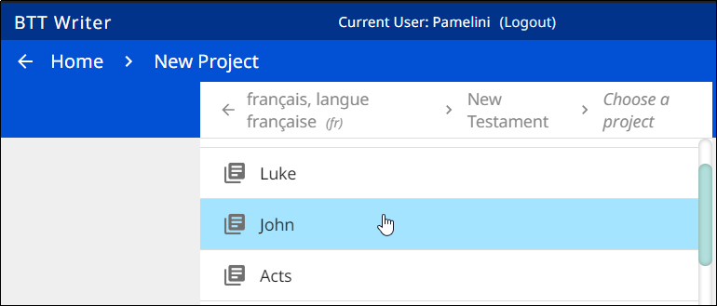
      2. If you are in Gateway Language Mode, you then also must select the type of translation – will you be translating text of either the ULB or UDB, or will you be translating Notes or Questions? (If translating Notes or Questions, you must first create a Text ULB project for the same target language/Bible book and then create another project for Notes or Questions.)
   2. **If you chose Other**, you next choose to translate either Open Bible Stories, Words (these are from the Bible), or Words OBS (these are from Open Bible Stories). The last two types are available only in Gateway Language Mode (See How do I set up to translate Bible resources (GL project)?.)  
      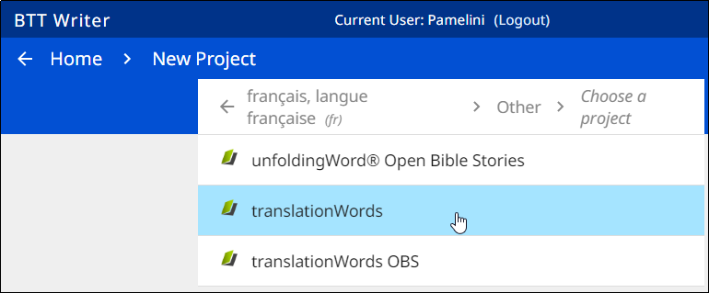

#### How do I select the source text language?

After selecting the category and type, the project is created and opens. If it is a Words project, it automatically uses an English source text. However, in other types of projects you need to select a source text before you can begin to translate. This is the text you will be translating *from*. You are not able to work in a project until you choose a source text language.

**Note**: If you are doing Gateway translation, be sure to select *English (en) Unlocked Literal Bible* as your source text. This is the source that has the resources (notes, words, and questions) attached to it.

In the translation project, complete the following steps to select the source text language:

* Click one of the rectangular icons with the + and – sign  (found at the right and at the center of the project window).  
  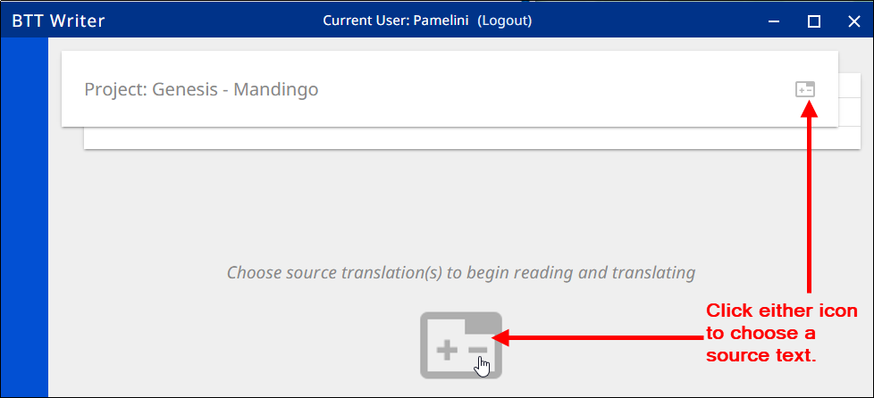
* Click the empty square box next to the desired source text and language. You can scroll down to see additional languages, or search by using the magnifying glass icon at the upper right of the *Choose source translations* box.  
  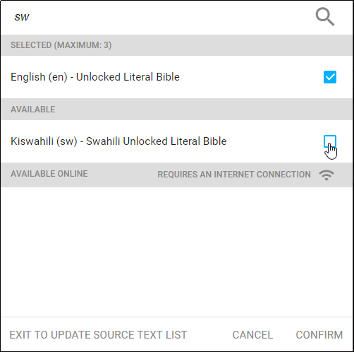 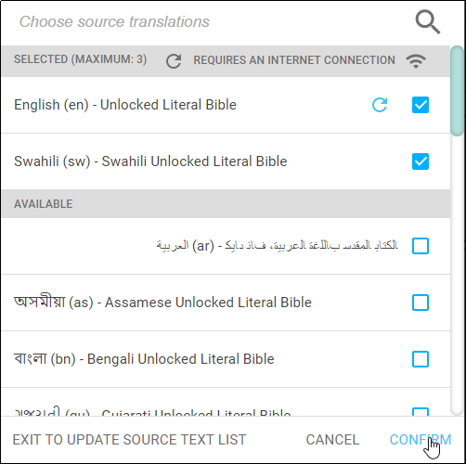  
   **Note**: You can choose up to three source texts; those selected are moved to the top portion of the *Choose source translations* box under the *Selected* heading.
  + Choosing multiple source texts enables you to compare them as you are performing the translation work.
  + For example, you should always choose the Unlocked Literal Bible (ULB) as a source if it is available in your language, but you may want to also choose the Unlocked Dynamic Bible (UDB) if it is available in your language because it may be easier to understand. Looking at the UDB may help you to translate or check a passage.

To save the selection(s), click **Confirm** at the bottom right of the *Choose source translations* box, OR click **Cancel** to close without saving the selected language.   
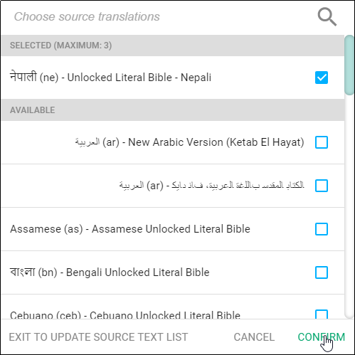

**WARNING:** You are not able to work in a project until you choose a source text.

### How do I change project properties?

If you make a mistake, after you have finished defining the project there are three project properties that you can change:

1. Target language:
   1. On the Home page, click the  icon next to the project whose target language you wish to change.
   2. On the information window, click Change next to the target language.  
      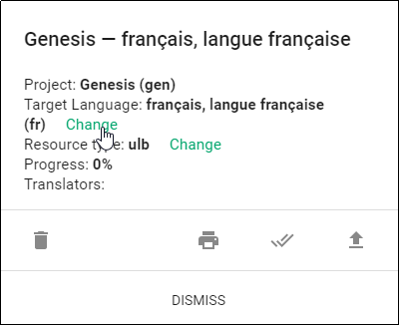
   3. The *Choose target language* window appears, enabling you to select a different target language. As soon as you select a language, a message displays to tell you the change is complete. Click **CLOSE** to dismiss the message.  
      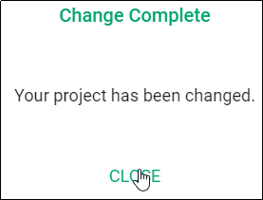
2. Resource type: You may wish to change the resource type (category) of the project.   
     
   For example, you tried to create a text project when you had Gateway Language Mode set to On. This would have created a Text ULB project, but you just want a regular text project for translating the Bible into a mother tongue language.   
     
   You can change the resource type as follows:
   1. On the Home page, click the  icon next to the project whose target language you wish to change.
   2. On the information window, click **Change** next to the resource type.  
      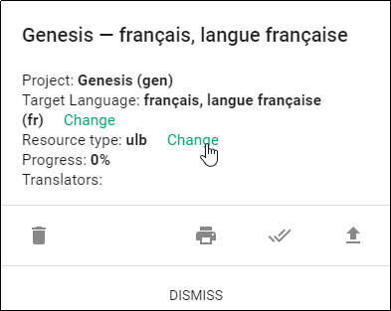
   3. The *Resource Options* window enables you to select a different type of resource. If you don’t want to make a change, you can click **CANCEL** to dismiss this window.   
      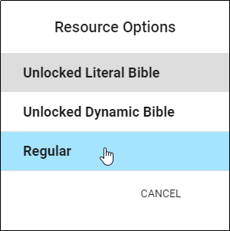  
        
      As soon as you select an option, a message displays to tell you the change is complete. Click **CLOSE** to dismiss the message.  
      
3. Source text: You can add or change source texts at any time while working in the project. To change the source text:
   1. With the project open, click the +- icon on the source text tab.  
      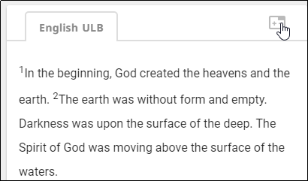
   2. Select the source text(s) you wish to use or click the checked box next to a selected source text to remove it.  
      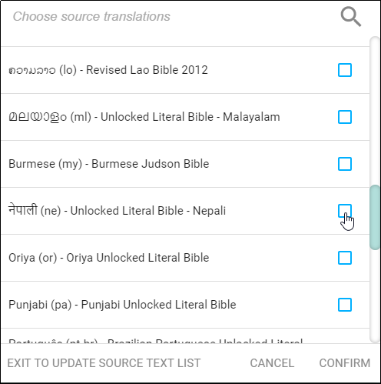 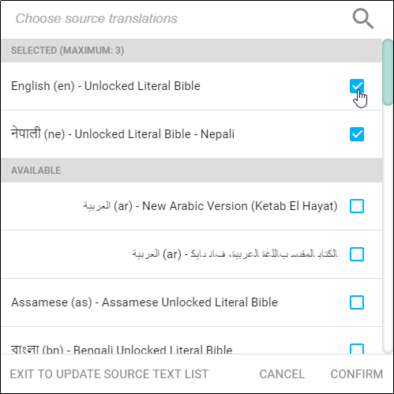
   3. Click **CONFIRM** to close the window or **CANCEL** to exit without saving the changes.  
      

## How do I work in BTT Writer?

The way you work in BTT Writer is different depending on the type of project.

### BTT Writer Layout

There are two main screens in the BTT Writer program:

* The Home screen, or *Your Translation Projects* screen, shows any existing projects. If there are no projects, then the Home screen displays a welcome message. The Home screen also shows the user name and a Log out button.  
  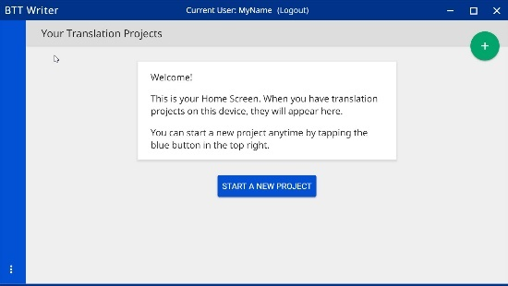 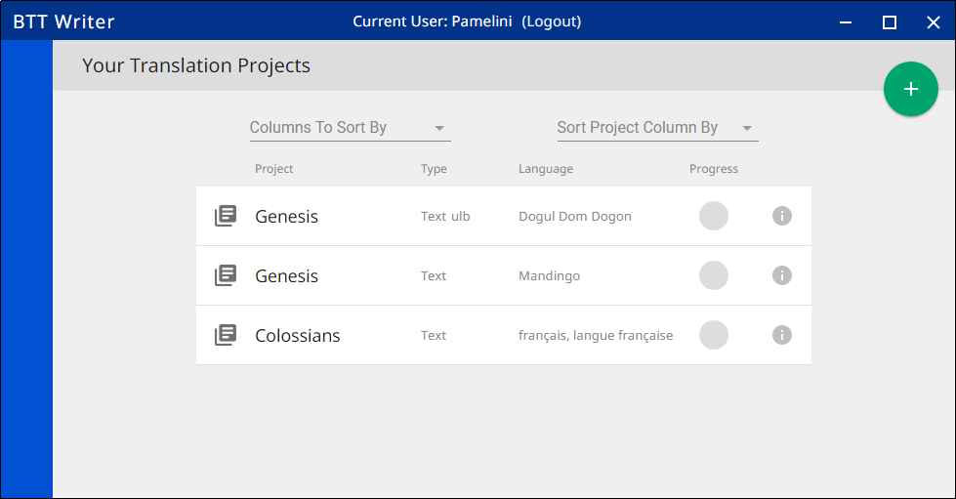

**Home screen with no existing projects Home screen with existing projects**

* The *Project* screen shows the source and target texts and can also display translation resources. The *Project* screen is where you perform all the translation work on a single project. It shows the source text and the translated text. Depending on the type of project, the *Project* screen can display three different views and contains navigation and menu icons to enable you to move around in the program. The navigation and menu icons are on the left of the screen.

The appearance of the project screen and the function of the navigation buttons work a little differently depending on the type of project in which you are working:

#### Working in a Words project:

A Words project is different from the other project types in that it is not tied to a specific book of the Bible. It shows words or terms from the entire Bible or Open Bible Stories.

##### Words project layout

A Words project has two panes. The left pane contains the English word or term and the definition of it. The right pane is the working area containing a notecard for each word.   
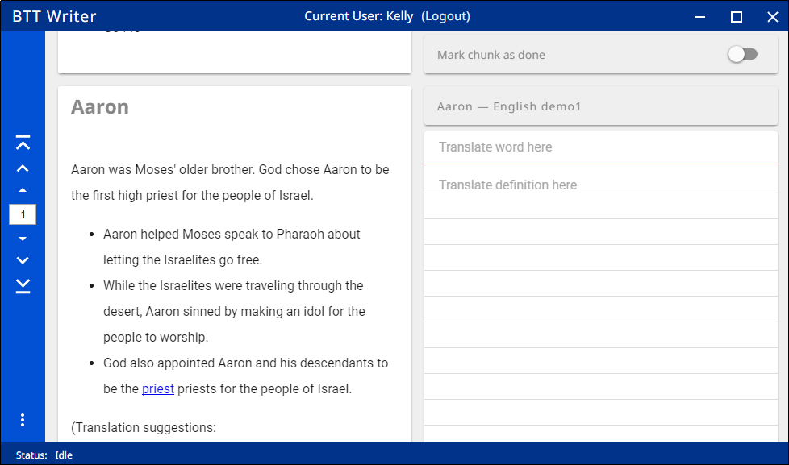

##### Words project navigation

You navigate in a Words project by using the navigation icons at the left:  
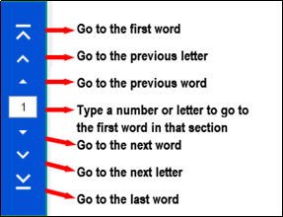

#### Working in a Notes project:

The Notes are tied to a specific part, or chunk, of Open Bible Stories or of a book of the Bible.

##### Notes project layout

A Notes project is divided into chunks of text. For each chunk there are four panes. From left to right, they are**:**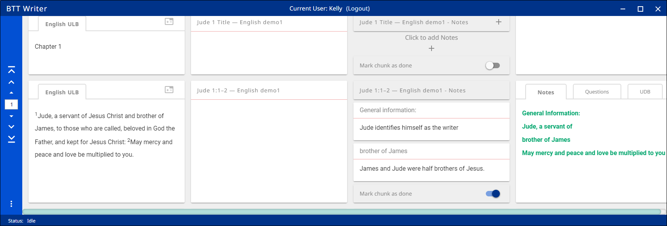

* The source text pane: If you have multiple source texts, they are displayed on tabs.
* The translation pane: If the project contains a translation in the target language, it is shown here, but cannot be edited.
* The working area, where you can create notecards for translating the notes.
* The resources pane, containing the resources, if any, for each chunk. Different resources are on the tabs.

##### Notes project navigation

To navigate in a Notes project, use the navigation buttons at the left of the screen:

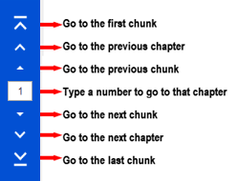

#### Working in a Questions project:

The Questions, like the Notes, are tied to a specific part, or chunk, of Open Bible Stories or of a book of the Bible.

##### Questions project layout

A Questions project has the same four panes as a Notes project, except that the Working pane (2nd from the right) enables you to translate Questions, rather than Notes.

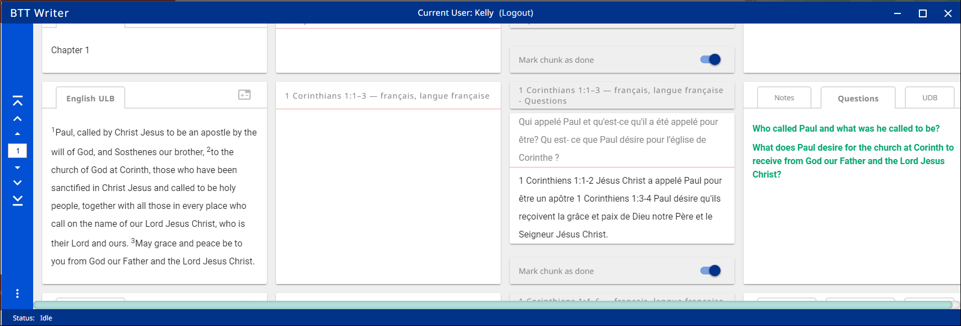

##### Questions project navigation

Navigation in a Questions project is the same as for a Notes project.

#### Working in a Text project:

The appearance and function of a text project can be different depending on the setting called Blind Edit Mode. This mode, which applies only to text projects, specifies whether the project allows for blind drafting, which changes the views available for the project. You should always use Blind Edit Mode for the initial translation of source text.

##### Text project layout

If you are not in blind edit mode, there are two views for a text project:

* **Edit-Review view**: The top icon at the left that looks like three vertical lines takes you to the Edit-Review view, where the source text is in the left pane, the translated text is in the middle pane, and the resources are on tabs in the right pane. The center pane can be edited.   
    
  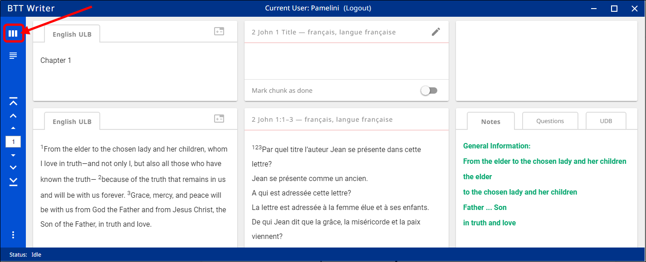
* **Read view:** The second icon at the left that looks like 3½ horizontal lines takes you to the Read view, which is a view of the entire chapter. The source text is initially visible, but if you click the “piece of paper behind the source text, you can see the translation. Editing is not available in the Read view.  
  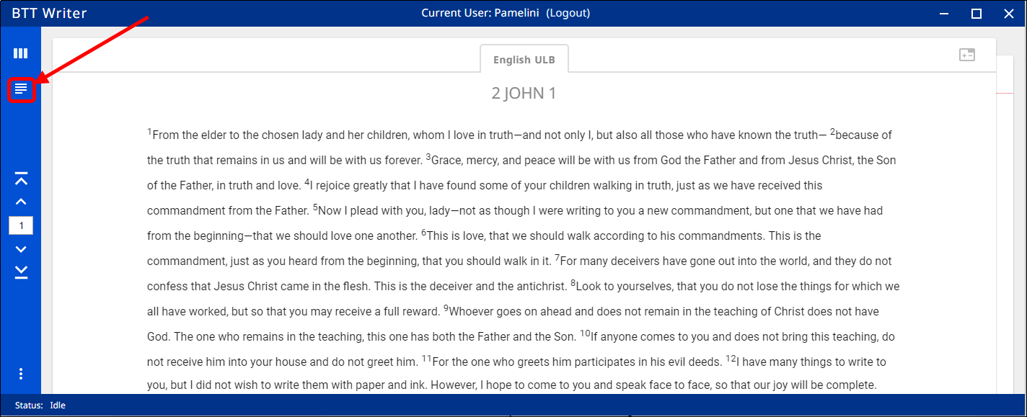

##### Blind Edit Mode:

If you change the settings to Blind Edit Mode, a third view is available for text projects.

To see this view:

* Open the Settings window from the Options menu that you access with the 3-dots icon:  
  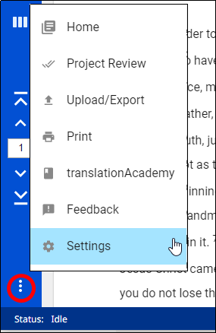
* Check the box beside the **Bind Edit Mode** setting.  
  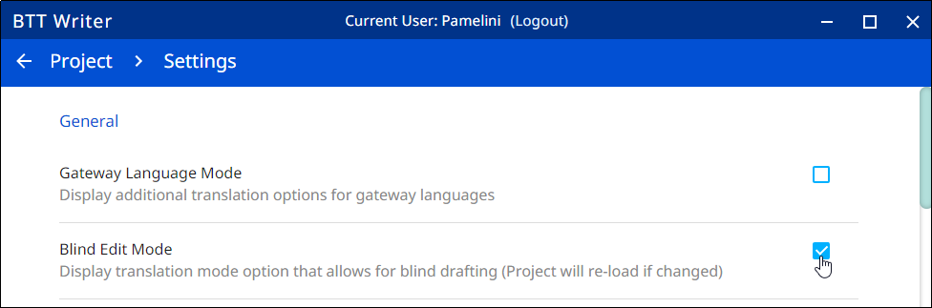
* Click **Project** in the breadcrumb area at the top of the screen to return to the project, which reloads in Blind Edit Mode.

You now have a third view available, accessed with the icon that looks like two sheets of paper.   
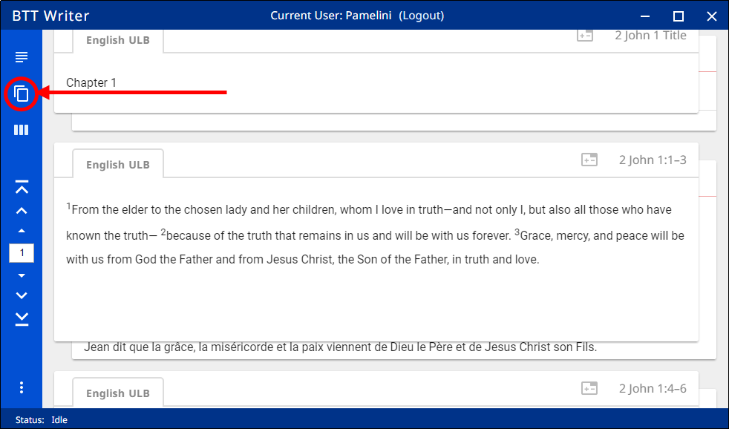

This **Blind Edit view** shows you the source text one chunk at a time, and you click the card behind the source text to translate. You cannot see the source and the translation at the same time, so it enforces a blind draft. This is the view you should use if you are doing an initial translation of Bible or Open Bible Stories text.

For additional information on translating in a text project, see Translating in a Text Project.

##### Text project navigation

The navigation buttons in a text project are different depending on the view:

* In the Blind Edit view or the Edit-Review view, the navigation buttons are the same as in the Notes or Questions projects.
* In the Read view, the buttons are similar except that there are no “previous chunk” or “next chunk” buttons, since the read view is not divided into chunks.  
  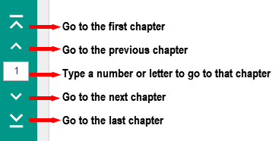

### Using the Options Menu

Click the **three dots icon**  at the bottom left of the screen to open the options menu. The Project screen and the Home screen have two different menus.

On the Home screen the options menu includes the following options:

* 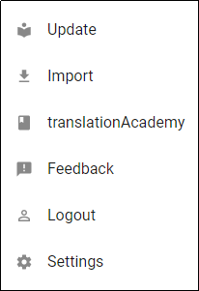Update (See: Updating Program Elements)
* Import (See: Importing a Project)
* translationAcademy – Opens a translation manual  
  in a separate window
* Feedback – Report a problem or make suggestions
* Logout
* Settings (See Modifying Program Settings)

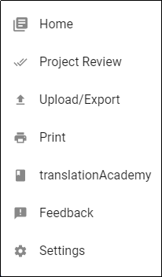  
On the Project screen the options menu includes:

* Home - returns to the Home screen
* Project Review (See: Reviewing the Project)
* Upload/Export (See: Uploading/Exporting Your Work)
* Print
* translationAcademy – Opens a translation manual in a  
  separate window
* Feedback – Report a problem or make suggestions
* Settings (See Modifying Program Settings)

Note that there are 3 options that can be selected from either the Home screen or the Project screen: translationAcademy, Feedback, and Settings.

## How do I translate in BTT Writer?

A basic translation process is explained here.

As you translate, be sure that you:

* Pray that God would help you make an easily-understandable, Scripturally-accurate translation.
* Translate everything that is in the source text language.
* Do not add anything that that is not necessary for comprehension.
* Always do your translation according to the Translation Guidelines (see <https://read.bibletranslationtools.org/u/WycliffeAssociates/en_tm/dc23f839f6/#translation-guidelines>).
* Always do your translation according to the Statement of Faith (see <https://bibleineverylanguage.org/statement-of-faith/>).
* Use the translation Notes to help you make a better translation (these resources are available within BTT Writer (see Using the Resources).

### Translating in a Text Project

To write the translation in your language:

For the initial translation, use Blind Edit Mode, which is organized to work with blind drafting.

You may want to read  <https://bibleineverylanguage.org/processes/mast/> to understand the steps of blind drafting translation.

To use BTT Writer to do blind drafting, perform the following steps:

1. Open the project for the story or book that is being translated
2. Click the Read view icon .
3. The screen of the Read view is arranged to appear like two sheets of paper, one behind the other, with the **Chapter or Story** view initially on top. In this view, read the source text, consuming the entire chapter.
4. Verbally retell what you have read to another person, preferably using the target language.
5. When you are ready to begin translating, click the Blind Edit icon .  
   **Note:** This icon is available only if you are using Blind Edit Mode.
6. The Blind Edit view appears and displays the text divided into chunks, which are sections that you should be able to retell without looking. Read a chunk over until you can remember what it says. 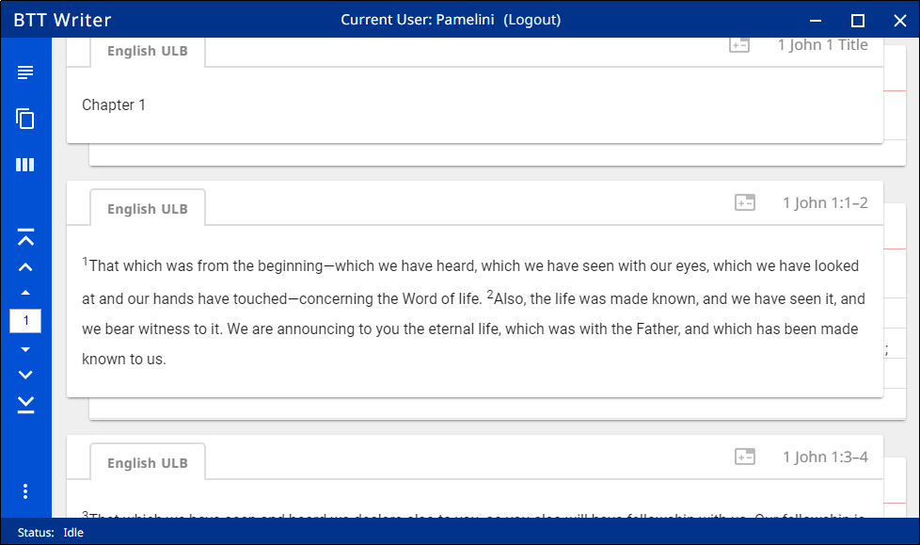
7. For the chunk you want to translate, click the blank paper behind the one containing the text.
8. Type in the translation for that chunk on the page. This should not be a word-for-word translation, but it should be expressed in a way that would sound natural to a native speaker of the language.  
   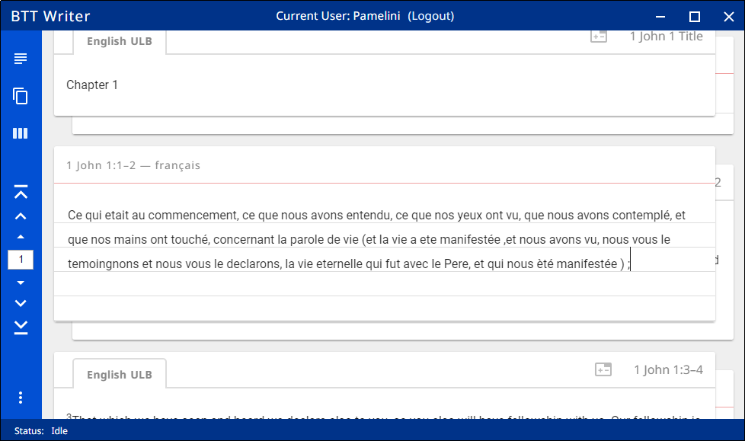  
   1. Start translating with a blind draft. Draft the chunk as well as you can without looking back at the text.
   2. Write everything that you remember about that chunk.
   3. Do not look back at the source text for this chunk until you begin the editing steps.
9. When you are finished working, navigate to the next chunk.
10. Perform steps 6-9 for each chunk of the chapter before moving to the checking steps.

#### Check and Edit Translated Text

When you use BTT Writer, you can create and change text. Use the **Edit-Review view** to edit existing work that you or another translator created. Your work is saved automatically every five minutes.

To enter the Edit-Review view, click the **Edit-Review view icon**  at the left of the page.  
  
In the Edit-Review view the source text is on the left and the translation work is on the right. You can compare the two and then edit the translation to include all details in the source text.

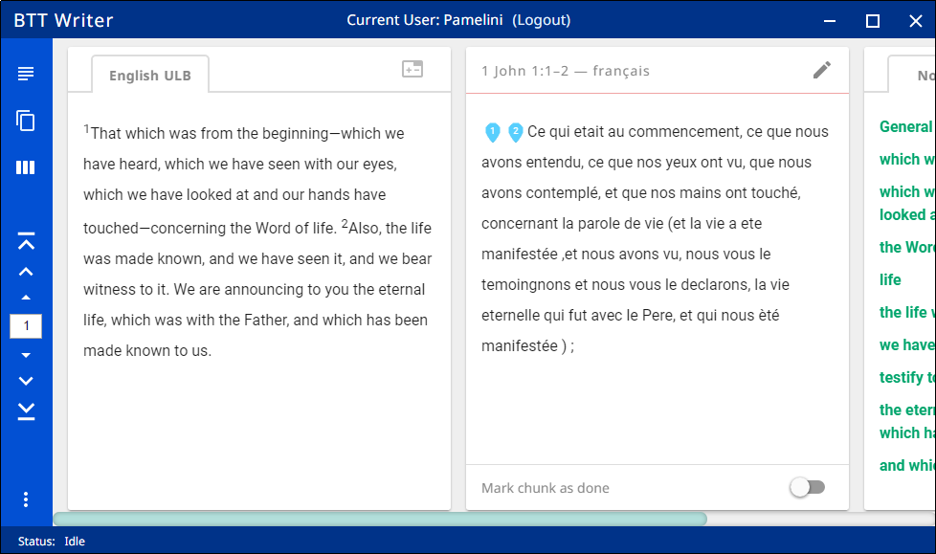

In the Edit-Review view you can access all of the Notes, Words and Questions that have been included in the program. See Using the Resourcesfor more information.

If you need to make changes in the translated text, perform the following steps:

1. Click the **pencil icon**  at the top right of the translated chunk.
2. Edit the text to include all details and correct any grammatical or spelling errors.
3. Click the check mark icon  when done editing.  
   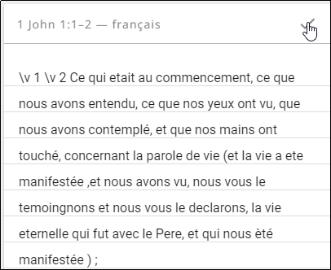
4. Place the verse markers (skip this step if you are translating Open Bible Stories, which are not divided into verses).
   1. There is a verse marker for each verse in the chunk.
   2. Click and hold each verse marker and drag it to the beginning of each verse, dropping it on the first word of the verse.  
      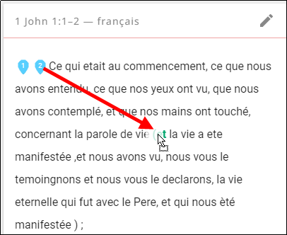 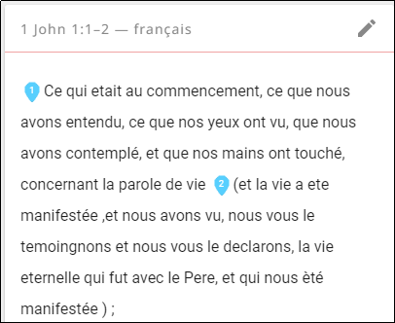
   3. Continue until all verses are marked with a verse number.
5. When you are finished working, use the toggle  at the bottom of the chunk to mark the translation of that chunk done. Slide the toggle to the right, or just click it, to indicate that the chunk is finished.  
   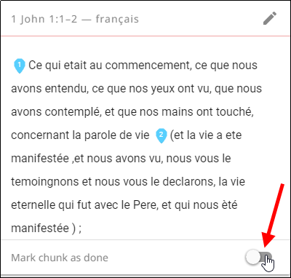
6. A message appears for you to confirm that the chunk is done. Click **Confirm** to indicate that the work is done or click **Cancel** to continue editing.  
   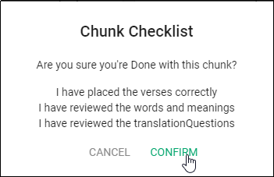

At any time you can click the toggle  to edit the chunk again. Use the above steps to edit.

#### Using the Resources

All of the Notes, Words and Questions are included in the BTT Writer program. They are available to use in any text project.  
**Note**: Currently the resources are attached to the English ULB, so they are available in BTT Writer only when the English ULB is used as the source text.

Click the **Check** icon  that looks like three vertical lines.

The resources are found in the far-right pane of the Edit-Review view.   
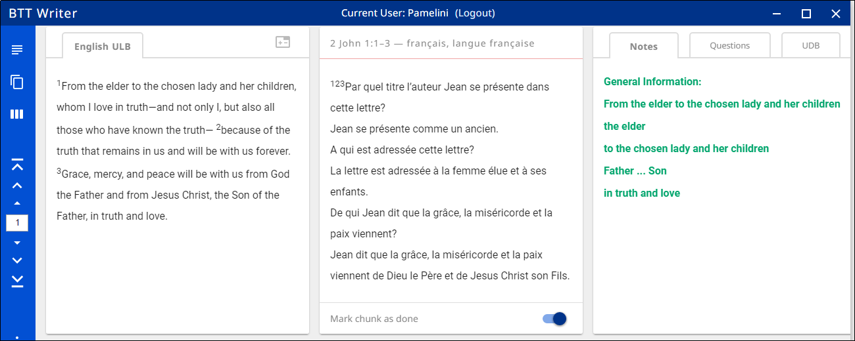

The Resources pane is divided into four tabs: Notes, Words, Questions, and UDB. The UDB tab simply contains the UDB (Unlocked Dynamic Bible) text for the chunk.  
  
 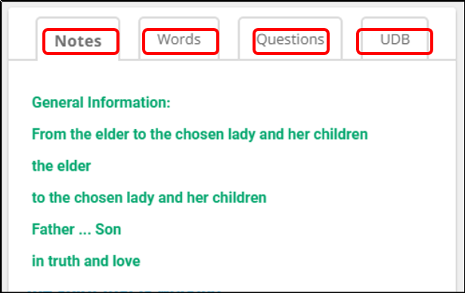

If there are no existing resources for a chunk, the resources pane is blank. If there are no resources of one of the types, then that tab does not exist on the resources pane. For example, if there are no Words for a chunk, then you would see only the Notes and Questions tabs on the Resources pane for that chunk.

* Click the **Notes** tab for the Notes.

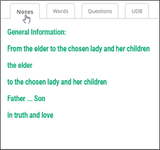  
The words or phrases are listed as they appear in the story or in the ULB. Click the phrase for help in understanding how to translate into the target language. See [Using the translationNotes](https://dw.door43.org/en/ta/vol1/translate/resources_types) for more information.

* Click the **Words** tab for the Words. The words are listed as they appear in the story on in the ULB. Click the word or phrase for help in understanding how to translate the word into the target language.   
  **Note**: If you do not see the Words tab in the resources pane, you may need to reload the source text (see Updating Program Elements: Downloading Available Source Texts).
* Click the **Questions** tab. The questions are about information as it appears in the story on in the ULB. Read the question and answer it according to the translated text. Click the question for the expected answer. If the given answer and the expected answer are the same, then the translation might be clear and accurate.

### Translating Resources

If you are translating resources (Translation Notes, Translation Words, or Translation Questions), you must have created your project in Gateway Language Mode (see How do I set up to translate Bible resources? and How do I select the project category?.

#### Translating Words

You translate the word or term above the red line and the definition in the area below the red line. Just click the notecard to begin typing your translation.  
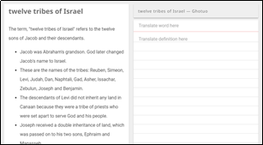

* Translate the Translation Word in the top section on the right panel.
  + Click above the red line on the 'Translate word here' words.
  + Type in the translation of the word or phrase.
* Translate the definition of the Translation Word: Click on the words 'Translate definition here' and start typing the translation of the definition. Write translations that will help Other Language translators understand how they can determine the best word to use in their language.

Bullets (the dot at the beginning of a line) are formed by typing an asterisk (Shift + 8) and a space.

The title of ‘**Translation Suggestions**:’ (only on some of the Translation Words)

1. Start the line with a hashtag (#) by holding down the shift key and pressing the 3 key.
2. Type in a space.
3. Translate the phrase “Translation Suggestions”.
4. Press the Enter key twice to insert a blank line between the title and the content.
5. Type in the translation of the content.

If there is a **parenthesis**, copy and paste the entire parenthesis at the end of the translation on the card. Copy: the parenthesis “(“, the words as they are between the parentheses, and the last parenthesis “)”. (

* You may translate only the word ‘see’ that is inside the parenthesis.
* Leave all the other words or characters in English.

When you have completed all of the content for the word, click on the toggle switch on the ‘Mark chunk as done’ bar.

**HINT:**

Sometimes you may want to know how a word is translated in the Bible of your language. There is a PDF that has a list of references where each translation word is used. Here is the link to the PDF -<https://cdn.door43.org/en/tw/v9/pdf/en_tw_v9.pdf>

#### Translating Notes

To translate notes, you click the Notes tab and then click each note reference to see the note text.

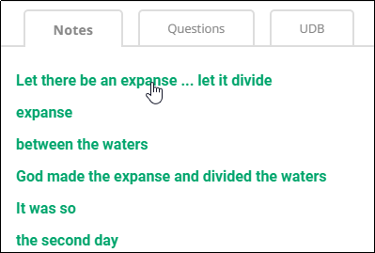 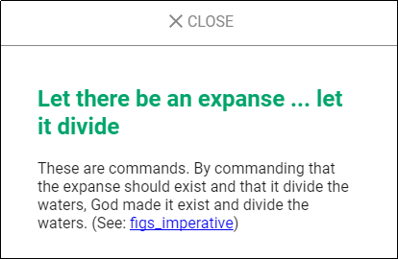

Then for each note in the chunk you click the plus sign in the work area to create a notecard, where you translate the note reference text above the red line and the note text below the red line. Create a notecard and translation for each note in the chunk.  
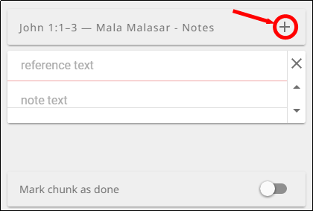

**Hint:** It may be helpful to first create all the notecards for a chunk, and then perform the translations. That way you are less likely to forget to translate one of the notes when there are multiple notes for a chunk.

You can move a notecard up or down within a chunk by using the up/down arrows in the right margin of the card. You can delete a card by clicking the X on the card – but be careful when you do so, because it is deleted immediately upon clicking the X with no opportunity to cancel the deletion.

Sometimes there will be a statement in parentheses at the end of the suggested translation that may look like this: (See: figs_metaphor). The word or words in blue are a link to a translationAcademy topic.

It is important to copy and paste the parentheses and the information inside of the parentheses to the notecard in column 3. To do this, highlight the entire parenthesis and left-click-hold-drag it to the card. If desired you may translate the word ‘see.’

#### Translating Questions

To translate the questions:

1. You first click the Questions tab in the Resources pane at the far right to see the questions.
2. You click each question to see the question and answer.
3. Then in the Working pane you click the plus sign to add a notecard for the question.
4. You translate the question above the red line and the answer below the red line.
5. For each chunk that has questions, create a notecard for each question and translate each question.  
   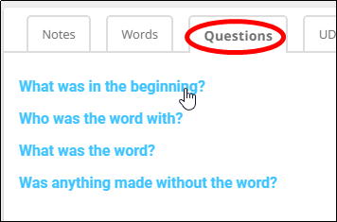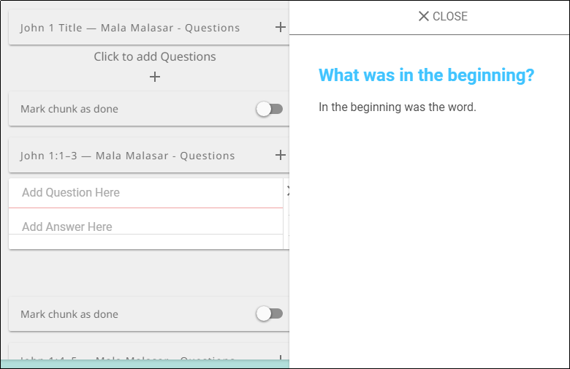

**Hint:** It may be helpful to first create all the notecards for a chunk, and then perform the translations. That way you are less likely to forget to translate one of the questions when there are multiple questions for a chunk.

You can move a notecard up or down within a chunk by using the up/down arrows in the right margin of the card. You can delete a card by clicking the X on the card – but be careful when you do so, because it is deleted immediately upon clicking the X with no opportunity to cancel the deletion.

When you have completed all the questions for the chunk, click the toggle switch on the ‘Mark chunk as done’ bar. The bar is located at the bottom of the 3rd column section

### Translating Footnotes

A footnote is additional text that usually appears at the bottom of a book’s page and is referenced within the page.

In BTT Writer, a footnote is shown as a black page icon that you click to display the footnote.

Footnotes can provide further explanation when:

* There are proper names, words or terms that differ between various Bible versions
* There are missing words or verses in the ULB. (There may be text in one Bible version that is not present in the ULB.)

To translate a footnote:

1. Copy the footnote.
   1. Click the footnote icon to open it (for example, in 1 John 1:4)   
      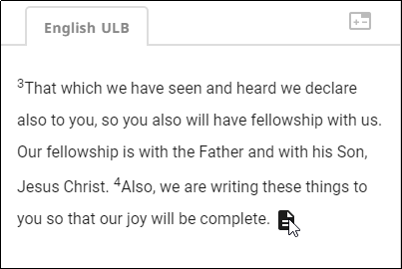
   2. Highlight the text of the footnote.
   3. Copy the footnote text – **[Ctrl + C]** on Windows.
   4. Dismiss the footnote.  
      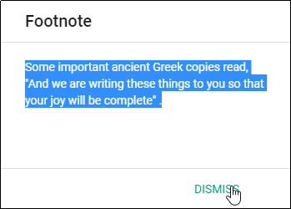
2. Paste the footnote into the translated text.
   1. If the chunk has been marked “done”, click the toggle at bottom right of the translated chunk.  
      
   2. Click the Edit icon (pencil).  
      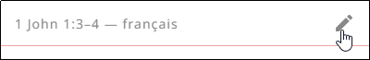
   3. Click the appropriate spot in the translated text.
   4. Paste the footnote text – **[Ctrl + V]** on Windows).  
      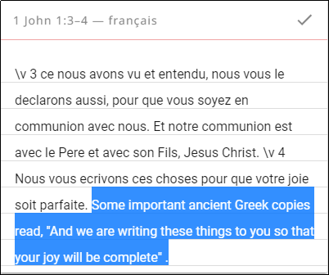
3. Add footnote coding. Footnote coding identifies the text as a footnote and separates it from the surrounding text. To add footnote coding:
   1. Type the following text at the beginning of the footnote, separated from the surrounding text by spaces: **\f + \ft**
   2. Type the following text at the end of the footnote, separated from the surrounding text by spaces: **\f\***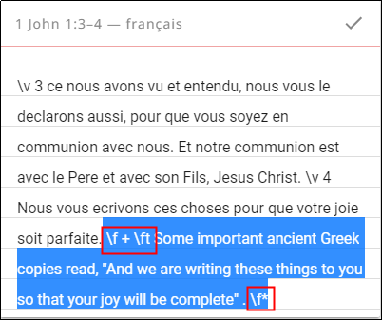
   3. If there is a quote within the footnote:
      1. Replace the beginning quotation   
         mark with: **\fqa** and a space
      2. Replace the ending quotation mark with: a space and **\fqb**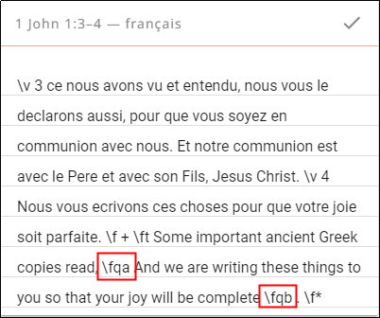
4. Translate the footnote text.
   1. Translate the text of the footnote.  
      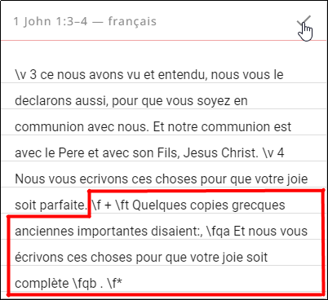
   2. Click the check mark to save the edits on the chunk.
   3. Mark the chunk as done.  
      

## Uploading/Exporting Your Work

When you work in BTT Writer, your text is saved every five minutes to your computer. Your work is not saved to the content server until you upload it.

While you are in a project in BTT Writer, click the 3-dot icon  to access the options menu. Select **Upload/Export** (the upward arrow icon ).   
**Note:** The upload/export option is not available in the 3-dot menu on the Home screen but is available only from the project screen.  
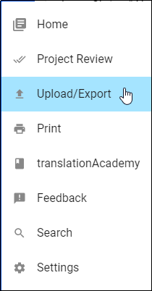

There are four options to choose from when exporting from BTT Writer.  
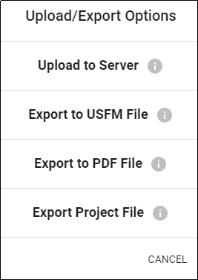

### Upload to the Server

**This requires an Internet connection.**  
This option copies your work to the online content server, making it available to be downloaded by other translators, merged with other projects, or used as an online backup. You can upload to the content server only if you have an internet connection and are logged in to a Server account. (The server to which you are uploading is specified in Settings 🡪 Server Suite; see Advanced Settings.)  
  
Follow this process to upload to the content server:

1. When you are in a project, click the 3-dot menu.
2. Click the bar **Upload to Server**.  
   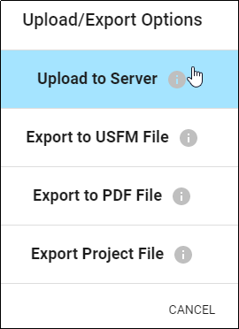
3. Wait while the upload process takes place.  
   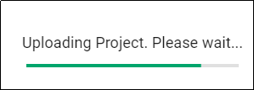
4. If you are connected to the Internet and signed into a Server Account, you will receive an "Upload Complete" message.   
   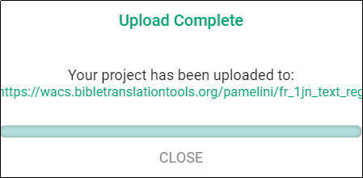
   1. The message displays a link to the online repository of the file.
   2. Click the link to open the repository OR click **Close** to close the window.
5. If you are NOT connected to the server, you will receive be an "Upload Failed" message.   
   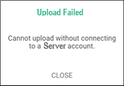
   1. Click **Close** to close the window.
   2. When you can be connected to the Internet, start the upload process again.

### Export to USFM File

This creates a file of your project with a usfm extension. Unified Standard Format Marker (USFM) is the international standard of Biblical text.   
  
Follow this process to export, or save, the project to a usfm file:

1. Click the bar **Export to USFM File**.   
   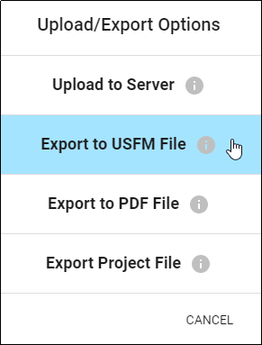
2. The computer's File Explorer window opens to the BTT Writer folder. Using the file manager, navigate to the desired location on the computer to save the file.   
   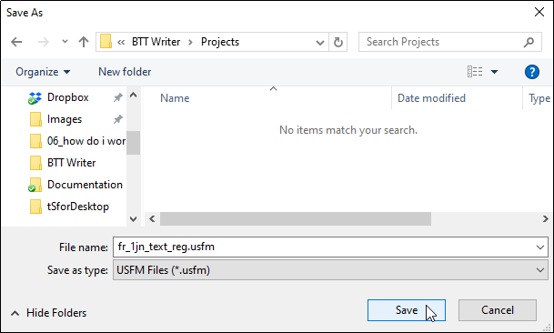
3. Rename the file if desired.
4. Click **Save**. A window shows a 'Project Exported' message.   
   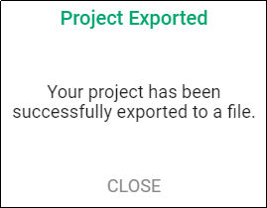
5. Click **Close** to close the window.

### Export to PDF File

This creates a pdf file of your project. Portable Document Format (PDF) is an international standard for sharing documents.  
  
Follow this process to export, or save, the project to a pdf file:

1. Click the bar **Export to PDF File**.   
   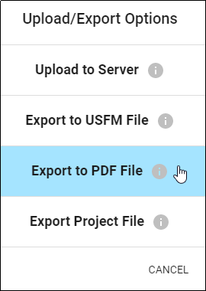
2. Choose the formatting options from the menu. You may choose any number of the options.  
   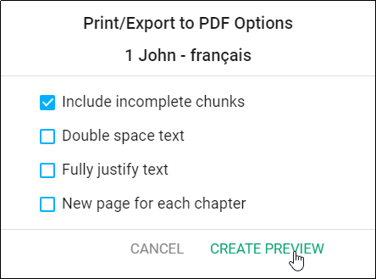
   1. Include incomplete chunks - these are chunks in the translation that have not been marked 'done.'
   2. Double space text - this adds an extra empty line between each line of text.
   3. Fully justify text - this creates a document where the text is all the way to the beginning and the end of each line of text.
   4. New page for each chapter - this creates a document where the start of each chapter is on a new page.
3. Click **Create Preview**. Wait for the document to be created.
4. Scroll through the preview to see what the document looks like.   
   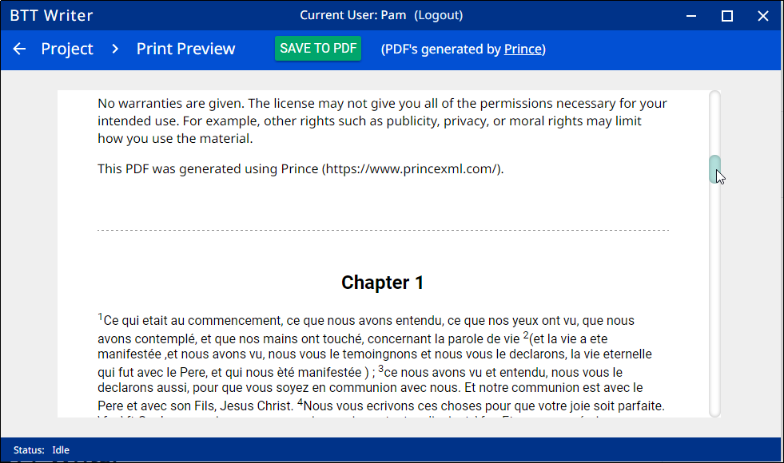
5. If changes are needed ...
   1. To the content - return to the Project.
      1. Click on **Project** at the left edge of the top bar.
      2. Make changes to the content.
   2. To the formatting of the document - return to the Project.
      1. Click on **Project** at the left edge of the top bar.
      2. Click the 3-dot icon to invoke the Options menu.
      3. Choose Upload/Export on the menu.
      4. Repeat steps 1 -5 above, choosing different formatting.
6. To save the document:
   1. Click **Save to PDF** on the top bar.  
      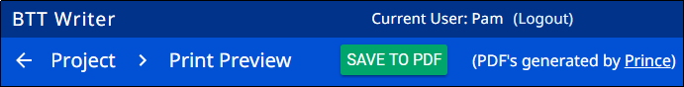
   2. The computer's File Explorer window opens to the BTT Writer folder. Using the file manager, navigate to the desired location on the computer to save the file.
   3. Click **Save**.  
      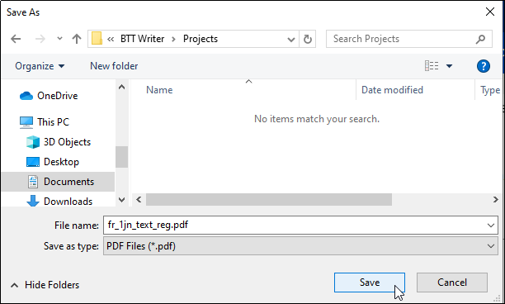
7. A window displays a 'PDF Created' message.   
   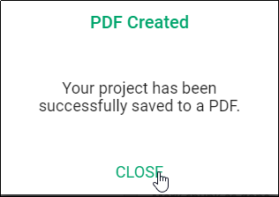
8. Click **Close** to close the window.

### Export Project File

This creates a file of your project with a tstudio extension. This can be used in any other BTT Writer version 11 program for either Desktop or Android.  
  
Follow this process to export, or save, the project to a tstudio file:

1. Click the bar **Export Project File**.   
   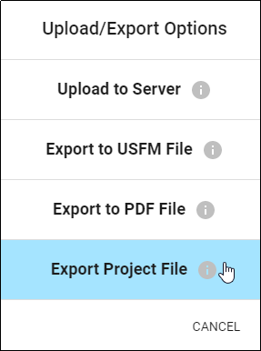
2. The computer's File Explorer window opens to the backup folder for BTT Writer. Using the file manager, navigate to the desired location on the computer to save the file.   
   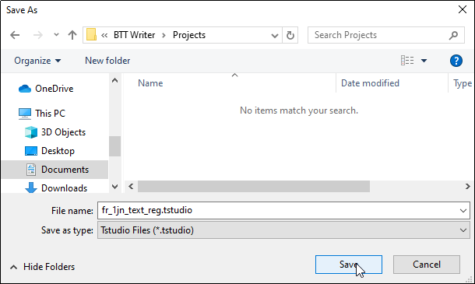
3. Click **Save**. A window displays a 'Project File Complete' message.   
   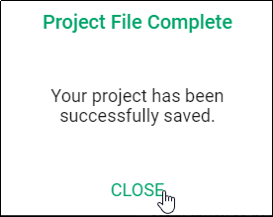
4. Click **Close** to close the window.

## Recovering Deleted Translation Text

If you accidentally delete a large amount of work, contact [helpdesk@techadvancement.com](mailto:helpdesk%40techadvancement.com).

## Importing a Project

The BTT Writer program enables you to import a project from various sources. To import a project:

1. Navigate to the Home page.
2. Click on the 3-dot icon at the bottom left of the window.
3. Select Import from the menu.  
   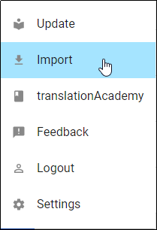

There are four options to choose from when importing to BTT Writer.

### Import from Server

If you are logged into BTT Writer with a Server account, choosing this option opens a screen with a list of all your online projects. (The server from which you import is specified in Settings 🡪 Server Suite; see Advanced Settings.)  
 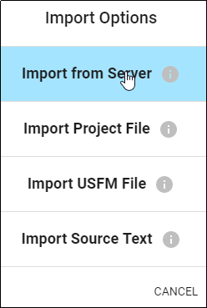

To search for another user's project:

* Remove your user name from the left search field.
* Type in the Server User Name of the user whose project you want to import.   
  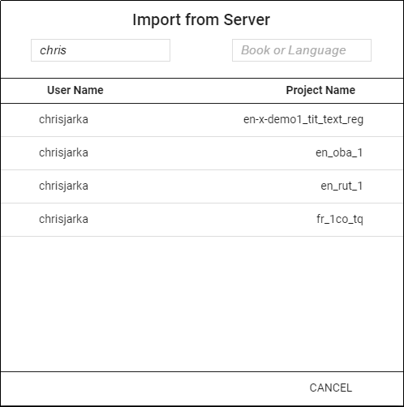

To search for a project by the book name or language:

1. Remove your user name from the left search field.
2. Type in either the book abbreviation or the language code in the right field. The example below shows a query for all translations from the book of 1 John.
3. Optional: type in a user's account in the User Name field to filter by the User.  
   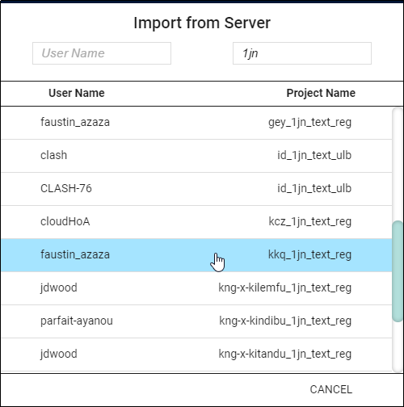
4. Click the desired file to import it or click **CANCEL** to close the option and return to the Import Options menu.
5. If you import the file, you receive a success message. Click **CLOSE** to close the window.  
   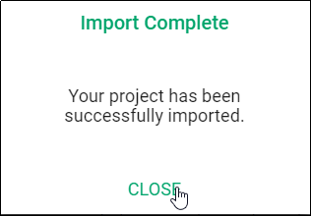

### Import Project File

This process imports into the program a BTT Writer project from a file on the computer. These are files that have an extension of tstudio.

1. Click **Import Project File** to import a project from the hard drive of the computer.  
   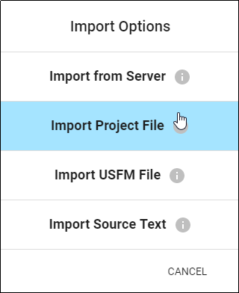
2. The program opens the file manager to the directory of the BTT Writer backups. Either choose one of the backup projects or navigate to the desired file.  
   Hint: you will be able to view only the files that have an extension of tstudio.  
   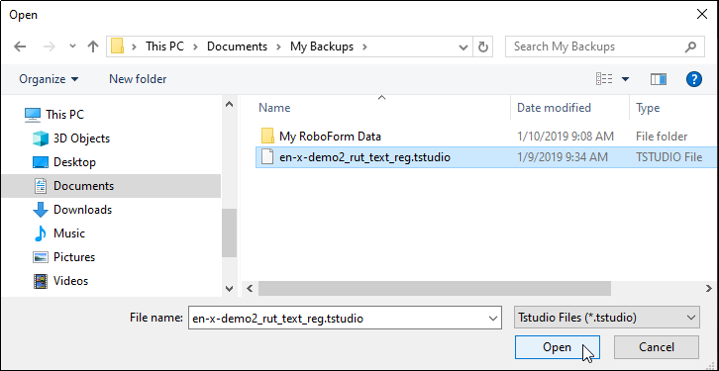
3. Click to select the desired .tstudio file, and then click **Open**.
4. The import begins; when the import is completed a window displays a success message. Click **CLOSE** to close the window.  
   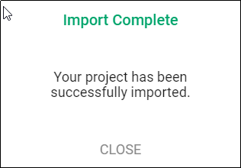

### Import USFM File

This process will import a file that is formatted as a USFM document.

1. Click **Import USFM File** to import a file from the hard drive of the computer.  
   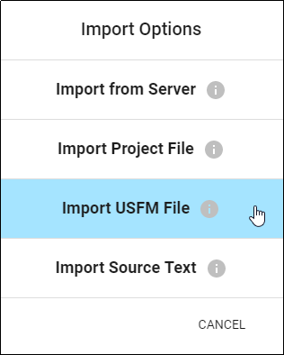
2. The program opens the file explorer to the BTT Writer backups folder. Navigate to find the desired file.  
   **Hint**: you will be able to view only the files that have an extension of .txt or .usfm.   
   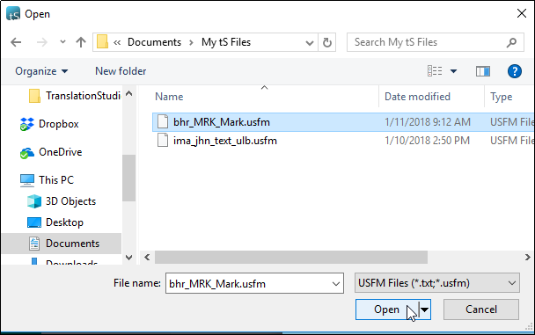
3. Make note of the language code contained in the file name, because you may need it in the next step. Click the desired file, and then click **Open**.
4. The USFM file itself may not contain the name of the target language. If not, you’ll need to tell BTT Writer what target language the project uses. On the 'Choose a Target Language' screen you can search for the language by typing its code in the search field. Use the language code that you made note of from the file name. Click the target language to select it.  
   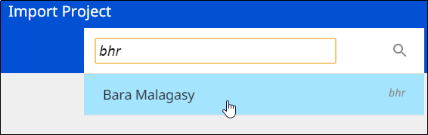
5. The remaining screens depend on what information is contained in the USFM file.
   1. You may be asked to choose a category. Click the desired category to select it.
   2. You may be asked to choose a book name. Click the desired book name to select it.
   3. You may be asked to choose the project type. Click the desired type to select it.  
      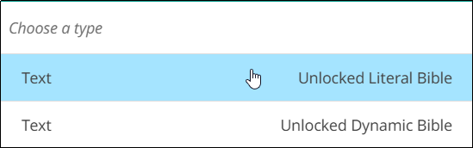
6. The import begins, and when the import is completed a window displays a success message.   
   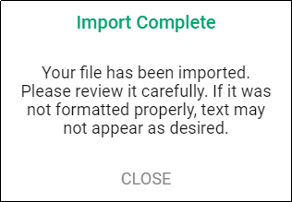
7. Click **CLOSE** to close the window.

### Import Source Text

If you have a file containing source text that you want to use for a project, you can select this option to do so.   
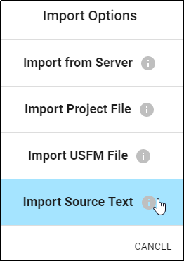

Refer to the information on <http://resource-container.readthedocs.io/en/latest/index.html> to create your own source text file that can be imported into the BTT Writer program.

Making the choice to import source text opens the File Manager. Navigate to the desired source text file, click the file name, and click **Open** to import it.

### Importing Duplicate Projects

If you are importing a project that is the same as a project already in the local program, you will receive a warning message that states:

* For a USFM file:  
  *Overwrite?  
  This target translation already exists.  
  Overwrite?*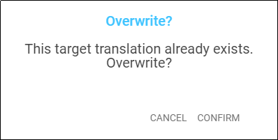
* For a project file:  
  *Project Already Exists  
  This project already exists locally. How would you like to proceed?*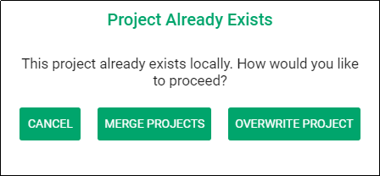

The possible actions for dealing with importing duplicate projects are:

* **Cancel**: Clicking **Cancel** closes the message and the project does not get imported.
* **Merge Projects**
  + The importing process continues.
  + When the message that the import is complete shows, click **Close**.
  + Open the project.
  + If the imported translation has recent changes, they now show in the text.
* **Overwrite Project**
  + **Warning**: Choosing to overwrite the project removes all information on the computer related to the previous local project and substitutes it with the information from the imported project.
  + We recommend that you do not choose this option if you have previously uploaded the project to the content server.
  + If you run into difficulty you can always contact helpdesk@techadvancement.com for help or submit a ticket using the following link: https://www.techadvancement.com/submit-ticket/.

### Merge Conflicts

Occasionally, there may be differences between the information in the program and the information that is in the imported project. This is known as a ***conflict***. When this happens, you see this message:

*Import Complete  
Your project has been successfully imported. There are 2 chunks that contain new conflicts that need your attention.*

Resolve the differences by following these steps:

* Click **Close** to close the message window.
* Open the project.
* Observe that there is a triangle icon in the left column. Click the triangle icon to view only the chunks with a conflict.
  + The text that was in the translation before the import is in a green box.
  + The text that is new is in the blue box.
  + Choose the text that has the preferred translation by clicking on that box.
  + Click **Confirm** to use the selected text. Click **Cancel** to not select the text.
  + The text that you did not select disappears.
* Repeat all the above steps until all the conflicts have been resolved by choosing the desired translations.
* If you run into difficulty you can always contact helpdesk@techadvancement.com for help or submit a ticket using the following link: https://www.techadvancement.com/submit-ticket/.

**NOTE**: Resolve all conflicts before doing another export or import of the project.

## Publishing Content

### Self-Publishing

When you upload your work to the content server it is automatically available online under your user account. This is referred to as self-publishing. You can upload to the content server as often as you wish to create a backup of your work. (See Uploading/Exporting Your Work.)

You can access a web version of your project at:

* For DCS: [https://git.door43.org/*user_name*/*project_name*](https://git.door43.org/user_name/project_name)
* For WACS [https://wacs.bibletranslationtools.org/*user_name*/*project_name*](https://wacs.bibletranslationtools.org/user_name/project_name). Click **See in Reader** to see a read-friendly version of your project.

(where *user_name* is your user name and *project_name* is your translation project). The BTT Writer app gives you the correct link when you upload.

You can also browse all works at:

* For DCS: <https://git.door43.org/explore/repos>
* For WACS: <https://wacs.bibletranslationtools.org/explore/repos>

From your Door43 or WACS project page you can:

* See the web version of your project with default formatting
* Download documents of your project (like a PDF)
* Get the links to the source files (USFM or Markdown) for your project
* Interact with others about your project

### Source Text Publishing

Source text publishing is required for all Gateway Languages so that they can be used as source texts by Other Languages. Note that **this process applies only to Gateway Languages**. There are several steps to the process of publishing your work.

#### Prerequisites

Before a Gateway Language translation can become a source text, the following prerequisites must all be met:

* Whole Resource - The whole resource must be translated and checked to the required level. Parts of resources (e.g. half of the Open Bible Stories, only a few chapters of a book of the Bible) cannot be published.
* Checking - A translation must have reached the appropriate checking level. For Bible translations, this is checking level 3: <https://bibleineverylanguage.org/faq/>.
* On the content server – The server must have the version that will be published. If the work was done on multiple devices, then it may need to be merged together. Get the help of a Content Tech to make merging easier (either email [help@door43.org](mailto:help@door43.org) for Door43 or [helpdesk@techadvancement.com](mailto:helpdesk@techadvancement.com) for WACS).
* Agreements - Everyone involved in the translation and checking must have agreed to the Statement of Faith, the Translation Guidelines, and the Open License. This can be done either by creating Server accounts or by physically signing the documents and digitizing them (scanning or photos). See [http://ufw.io/forms](http://ufw.io/forms%20) for downloadable agreement forms.

#### Reviewing the Project

You can use BTT Writer to ensure that the project is complete and that all contributors are listed. You can perform project review by completing the following steps to publish your work:

1. In BTT Writer, load your project.
2. Click the **3-dot icon**  to access the options menu.
3. Select the **Project Review** (the double check marks icon).
   1. On the **Project** tab -- Review sections of the book for final review.
      1. We suggest that you review any chunk that has a review button. These are chunks that are not marked done.
      2. Click on the Review button to finish translating or set the verse markers, and then slide the 'done' toggle.
   2. Select the **Contributors** tab -- This is where you enter who translated the work. Remember that the names will be publicly available.
      1. Click the **Name or Pseudonym** line and enter a contributor’s name.
      2. Click the check box to indicate that this person has agreed to the terms of use.
      3. Click **Add Contributor** to add the translator.  
         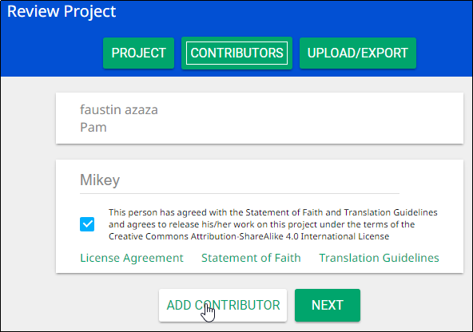
      4. When you have finished adding contributors, click **Next** to continue.
   3. When you either click Next in the step above, or click the Upload/Export tab, you are presented with Upload/Export Options.
      1. Select **Upload to Server** (requires an Internet connection).
      2. A pop-up message appears after a successful upload. This pop-up message includes the repository that the translation is in on the content server.
      3. Click on the link to view the repository.

#### Source Text Request Form

Once you have met the prerequisites, you may fill out the source text request form at [http://ufw.io/forms](http://ufw.io/forms%20). A few notes about the form:

* You must have a Server account to create a request.
* You must include the names or pseudonyms of everyone involved. You must also include their Server usernames if you are not attaching signed license agreements for them.
* Note that the information you enter will be public and will become a part of the front matter of the source text.

After you submit the form, you will be contacted if anything is missing. Once the request has been approved, it will go into the publishing queue where a developer will work to make the translation a source text. You may also be contacted by the developer if there are any issues encountered during the publishing process. You will be notified when the process is completed, and you may review a PDF of the work.

#### Questions Regarding the Request to Publish Form and Process

##### What Happens After Text is Approved?

When the Request to Publish is approved, the text is made available on <https://bibleineverylanguage.org/translations/> for online viewing, as a downloadable, print-ready PDF.

##### Can Text Be Changed After Level 3 Checking?

Approved text can always be modified in BTT Writer even after all checking levels are completed, HOWEVER if you or another user were to submit a Request to Publish for text that has already completed Level 3 checking, there would be questions regarding the reason for overwriting the previously published and checked materials. The approver will look to see who contributed to the change and may contact the requestor and others involved with the translation of the text in question to ensure the changes are valid.

##### Must All Contributors Be Named?

Due to copyright laws (and these exist no matter what country you are in and no matter what people tell you about laws in that country), you must list every contributor as they prefer to be mentioned.  Normally this is the person's name or pseudonym.

## Modifying Program Settings

There are several settings for the BTT Writer program that you can view or modify.

To open the settings window, click the 3-dot icon  at the bottom left of the screen and select **Settings** from the options menu. The Settings window is the same regardless of whether you invoke it from the Home screen or from a project screen.  
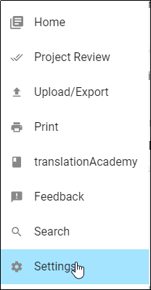

Click the **Back Arrow** at the top left of the screen to exit the Settings window.  
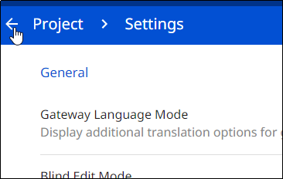

The Settings window enables personalization of the program. It also displays useful information. Settings are divided into four categories:

1. General
2. About
3. Legal
4. Advanced

### General Settings

The General settings are as follows:  
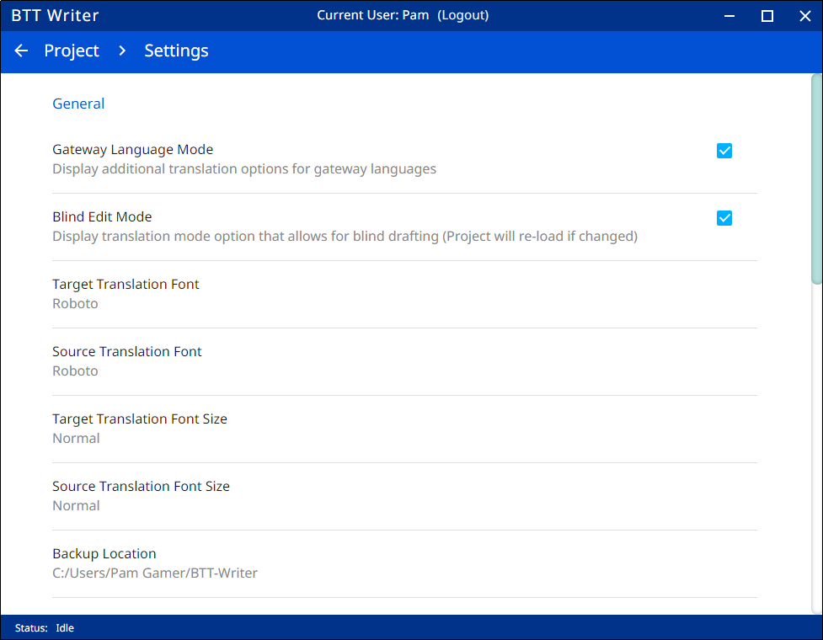

1. **Gateway Language Mode**: Select this setting if you are working to translate Bible resources into a gateway language. See How do I set up to translate Bible resources (GL Project)?.
2. **Blind Edit Mode**: Select this setting to enable the Blind Edit view for a text project. See Blind Edit Mode.
3. **Target Translation Font**: The font of the translated text
   1. The name of the chosen font is displayed.
   2. To change the displayed font of the target translation, click anywhere in the field**.**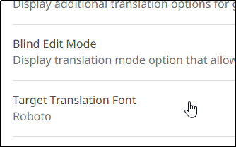
   3. A pop-up window shows the available fonts. Scroll through the names of the fonts and click the name to select the desired font, and then click **CONFIRM**. (If you have installed a font to your computer but it does not appear in the list, see Adding Fonts.)  
      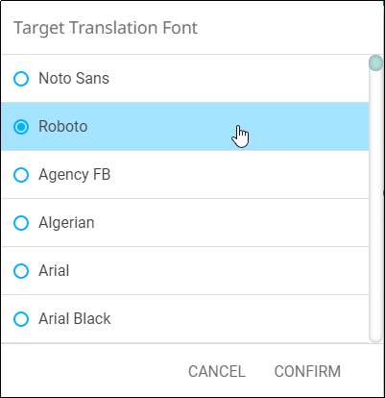
4. **Source Translation Font**: The font of the source text
   1. The name of the chosen font is displayed.
   2. Click **Source Translation Font** to change the displayed font in the source.
   3. A pop-up window shows the available fonts. Scroll through the names of the fonts and click the name to select the desired font. When you have selected a font, the pop-up window disappears. (If you have installed a font to your computer but it does not appear in the list, see Adding Fonts.)
5. **Target Translation** **Font Size**: The size of the translated text
   1. The size of the chosen font is displayed. Click **Target Translation Font size** to change the displayed font size in the text.
   2. A pop-up window shows the available sizes. Click the desired size to select it. When you have selected a font, the pop-up window disappears.  
        
      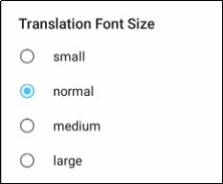
6. **Source Translation Font Size**: The size of the source text font
   1. The size of the chosen font is displayed.
   2. Click **Source Translation Font Size** to change the displayed font size in the text.
   3. A pop-up window shows the available sizes. Click the desired size to select it. When you have selected a font size, the pop-up window disappears.
7. **Backup Location**
   1. Shows where backups are stored on your computer. The program automatically backs up your work every 5 minutes.
   2. Click Backup Location to change where backups are stored.

### About Settings

These settings cannot be changed by the user; they are only for display.  
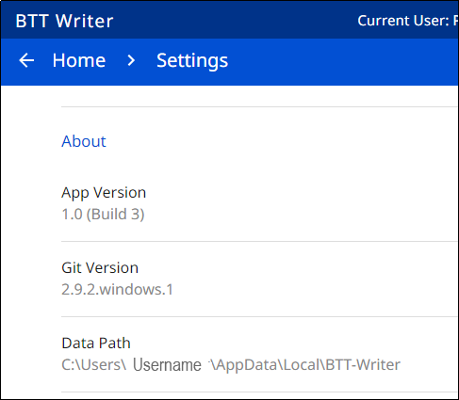

1. **App Version** - The version of BTT Writer
2. **Git Version** - The version of Git (version control software)
3. **Data Path** - The path to data used by BTT Writer

### Legal Settings

Click **Legal** to view important legal information.   
  
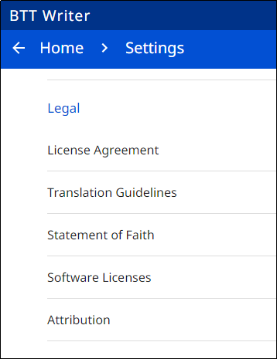

* **License Agreement** - read what you are permitted to do with the content in the program and the content that you create.
* **Statement of Faith** - you, the user of the program, agreed to this the first time the program was started. Read this to review what the Essentials Beliefs are.
* **Translation Guidelines** - read this document to learn about the guidelines that can help the translator clearly, accurately and naturally translate the text.
* **Software Licenses** - this file contains all the licenses for the various software programs that are used to create the BTT Writer program.
* **Attribution** - read this document to learn about the restrictions of using the derivative works and name branding.

### Advanced Settings

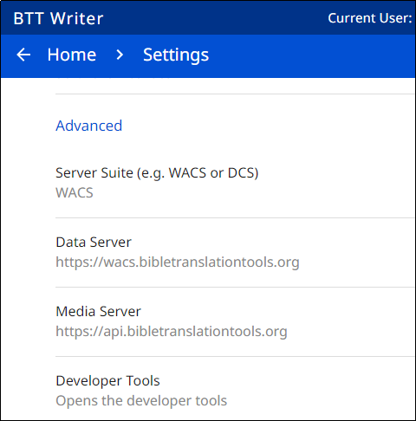

* **Server Suite (e.g. WACS or DCS):** Specifies the content server where you can upload or import translations. Choose between the Wycliffe Associates Content Server (WACS) or the Door43 Content Server (DCS). Changing this setting also automatically changes the values for the next 2 settings shown below.   
  **Note:** If you change this setting, you are prompted to close and reopen the BTT Writer program.
* **Data Server:** The WACS or Door43 server, depending on what you choose for Server Suite. Don't change this value unless directed to do so by a support technician.
* **Media Server:** The WACS or unfoldingWord media server, depending on what you choose for Server Suite. Don't change this value unless directed to do so by a support technician.
* **Developer Tools**: You should not open developer tools unless directed to do so by a support technician.

### Adding Fonts

If you install a new font on your computer, how can you get BTT Writer to use that font? Fonts of the target and source text can be changed in BTT Writer’s General settings, but what if your new font is not visible in the font list?

**For Windows**

Windows 10 stores user-installed fonts in the Microsoft\Windows\Fonts subdirectory of the user’s local directory:

c:\Users\[user name]\AppData\Local\Microsoft\Windows\Fonts

Microsoft can use these fonts in its applications, such as Word, but BTT Writer looks for fonts only in the c:\Windows\Fonts directory.

To fix this, you can copy the font file from the user’s local directory to the Windows Fonts directory. However, you can’t use File Explorer to do this, because when you open c:\Windows\Fonts in File Explorer, it displays all installed fonts, including the user-installed ones that are not actually in that directory.

To copy the font to where it is visible to BTT Writer, you must run the command prompt as an administrator and then use the copy command to copy the font file from the user’s local directory to the c:\Windows\Fonts directory. To do this, perform the following steps:

1. Press the **[Windows] key** (or click the Windows icon in the task ribbon) to invoke the Start menu.
2. Start typing the word **command** to search for the command prompt.
3. Windows displays the search results. If Command Prompt is not highlighted, click the **right arrow** next to Command Prompt.
4. On the right side of the window, click **Run as Administrator**.
5. If prompted to allow the app to make changes, click **Yes**.
6. In the command prompt screen, issue the following command:

**copy c:\Users\[user name]\AppData\Local\Microsoft\Windows\Fonts\[file name] c:\windows\fonts**

where [file_name] is the name of the font file (such as bamini.ttf) and [user name] is the directory that corresponds to the user who installed the font.

You should now be able to see the new font in BTT Writer’s font list when you try to change the target or source text font in settings. If you don’t see the new font at first, try closing and reopening BTT Writer.

**For MAC**

For Mac users, the same problem can be resolved by copying the font to /Library/Fonts.

**For Linux**

For Linux users, install the font to /usr/share/fonts/truetype. Although the other fonts in this folder are in subfolders, if you put the fonts you install into subfolders, BTT Writer will be unable to find them.

## Updating Program Elements

Select **Update** from the Options menu on the Home page to see the options for updating program elements. You must be connected to the internet to exercise any of the update options.

The options are: 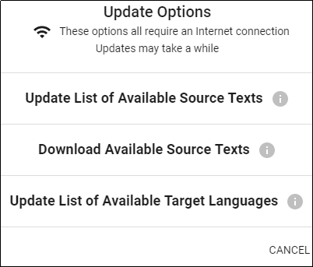

* Update List of Available Source Texts
* Download Available Source Texts
* Update List of Available Target Languages

### Updating Source Text Lists

To update the source text lists, select **Update List of Available Source Texts** from the Update menu. This process updates ONLY the list of the available source texts, not the texts themselves. The purpose of downloading only the *list* of source texts is to reduce the number of files that would need to be downloaded. You will need to download a source text before using it.

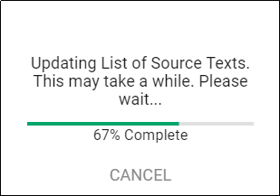

Updating the list takes several minutes, so you need to wait for the process to complete.

**Note:** You may receive a notice that the process is not complete; sometimes this notice is not accurate.

When the process is complete, the program notifies you of the number of new source texts that are available to download. You may close the window.   
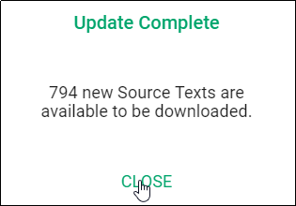

The program now presents you with choices to download selected source texts. If you don’t want to download now, click **Home** in the breadcrumbs at the top of the page.   
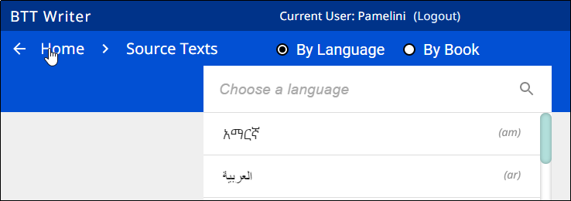

If you do wish to download one or more source texts, the process is shown below.

### Downloading Available Source Texts

When you choose **Download Available Source Texts** from the Update menu, you first must choose which source texts to download. You have a choice to look at the source texts in one of two ways:

* By Language – this choice enables you to download multiple books at once for a single language. If you choose to view by language and select a language, only the books that are available for that language are shown. Other books may become available as more source texts get translated and checked.  
  **NOTE**: The choice of ‘By Language’ also enables the downloading of the Translation Words and OBS resources.  
   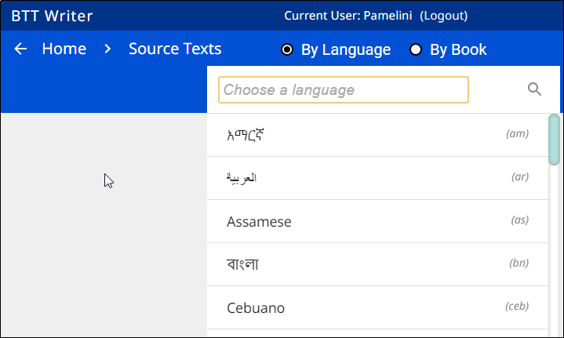
  1. Type the language name in the search box or scroll to the desired language.
  2. Click the language to select it (if you click a language by mistake, click the back arrow next to the language to return to the language list.)  
     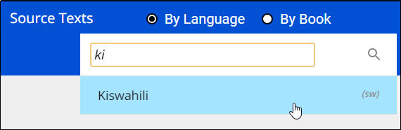
  3. On the Choose Category list, click to select a category. Some languages have more or fewer categories, depending on what source texts are available. The Category of ‘Other’ contains the Translation Words (bible), OBS source, and OBS Translation Words. (The best choice is to choose the Translation Words (bible).)  
     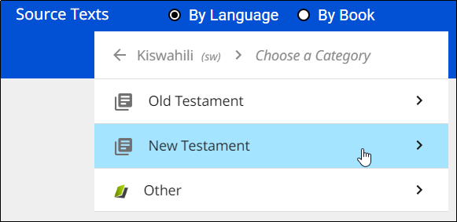
  4. Click the check box next to the source text(s) you wish to download, and then click **Download.**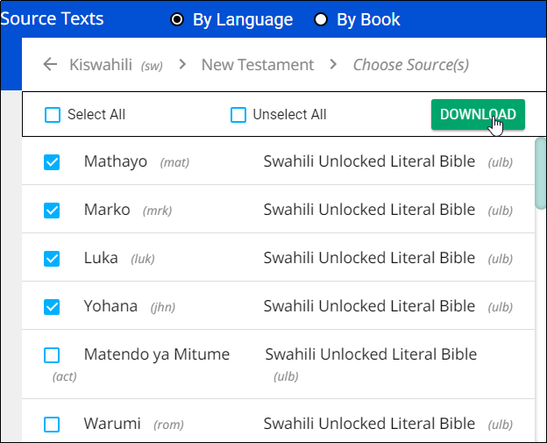
  5. The selected text(s) download (this may take a few minutes) and then you should receive a success message. Click **Close**.  
     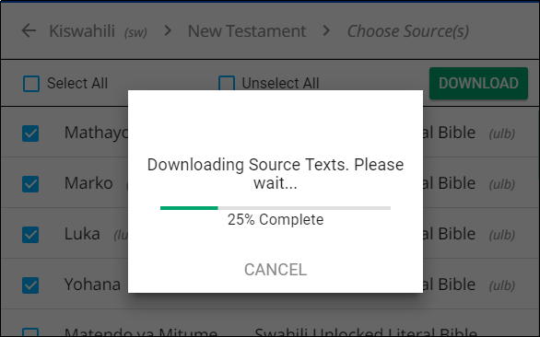 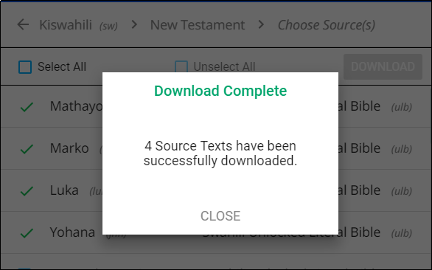
  6. The downloaded texts have a green check mark next to the name on the Source list.  
     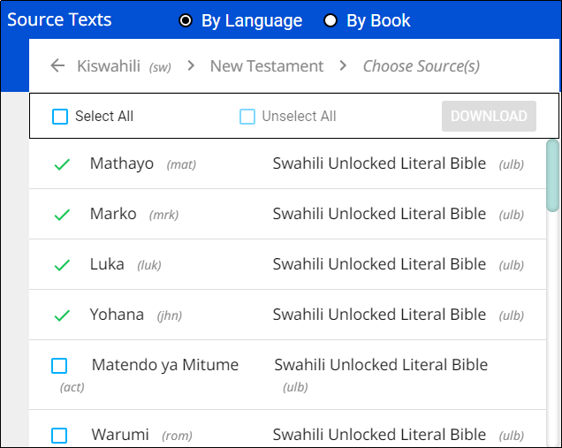

**Note:** You may receive an unsuccessful message. One or more choices have a red x next to the name. This source text was not downloaded. You may try again to download the texts that were not successfully downloaded.

* By Book – this choice enables you to download multiple languages at once for a single book. If you choose to view by book, only the languages for which that book is available are shown. Other books may become available as more source texts get translated and checked.  
  **NOTE**: The choice of ‘By Book’ also enables the downloading of the Translation Words (bible and OBS resources.
  1. Click to select a category. The possible categories are:  
     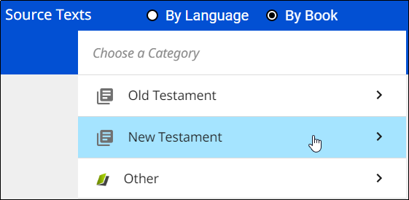
     + Old Testament: Opens a list of Old Testament books
     + New Testament: Opens a list of New Testament books
     + Other
       - Open Bible Stories
       - Translation Words
       - Translation Words OBS

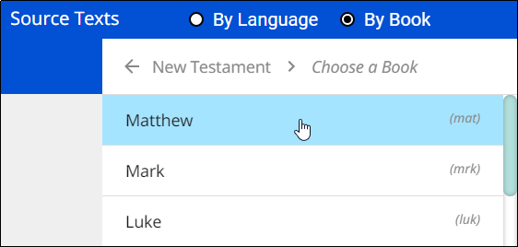

* 1. Once you have selected a book category, a list of available source texts opens. Select one or more source texts and click **Download**.  
     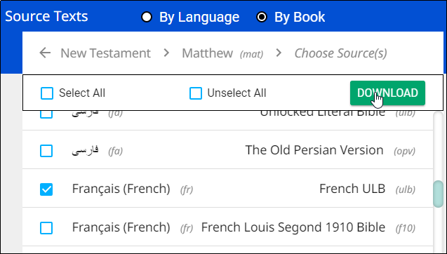
  2. The selected text(s) download (this may take a few minutes) and then you should receive a success message. Click **Close**.
  3. The downloaded texts have a green check mark next to the name on the Source list.  
     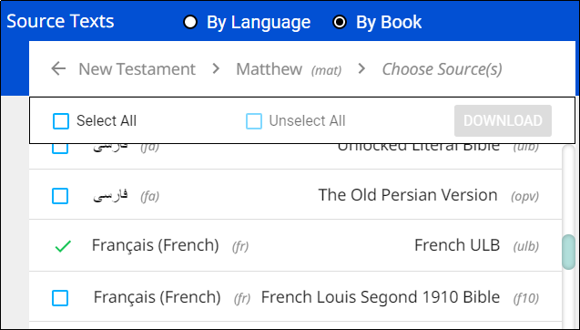

**Note:** You may receive an unsuccessful message. One or more choices have a red x next to the name. This source text was not downloaded. You may try again to download the texts that were not successfully downloaded.

### Updating List of Available Target Languages

Select **Update List of Available Target Languages** from the Update menu to update the list of all the target languages available in the program.   
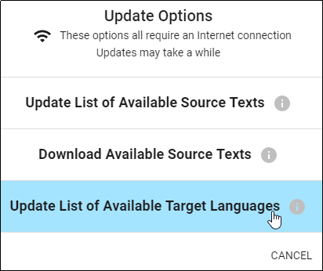

A progress window opens. At the end of the process a message shows how many new target languages were added. Click **CLOSE** to return to the Home screen.  
